Year  8 |  | Transformations and Congruence | Non Calculator  Test
Skills and Knowledge Assessed:  - Describe translations, reflections in an axis, and rotations of multiples of 90° on the Cartesian plane using coordinates. Identify line and rotational symmetries (ACMMG181)  - Define congruence of plane shapes using transformations (ACMMG200)  - Develop the conditions for congruence of triangles (ACMMG201)  - Establish properties of quadrilaterals using congruent triangles and angle properties, and solve related numerical problems using reasoning (ACMMG202) |  |  | Name___________________
Answer all questions in the spaces provided on this test paper by:
Writing the answer in the box provided.
or
Shading in the bubble for the correct answer from the four choices provided.
Show any working out on the test paper. Calculators are not allowed for this section.
Use geometric instruments to draw the image after EFGH is reflected in the line AB.
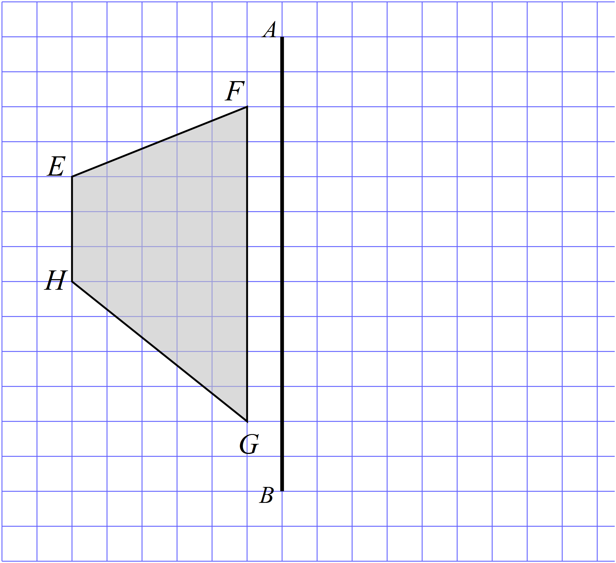

How many axes of line symmetry does the shape below have?


axes

Use geometric instruments to draw the image after PQRS when it is translated in the distance and direction of the arrow.
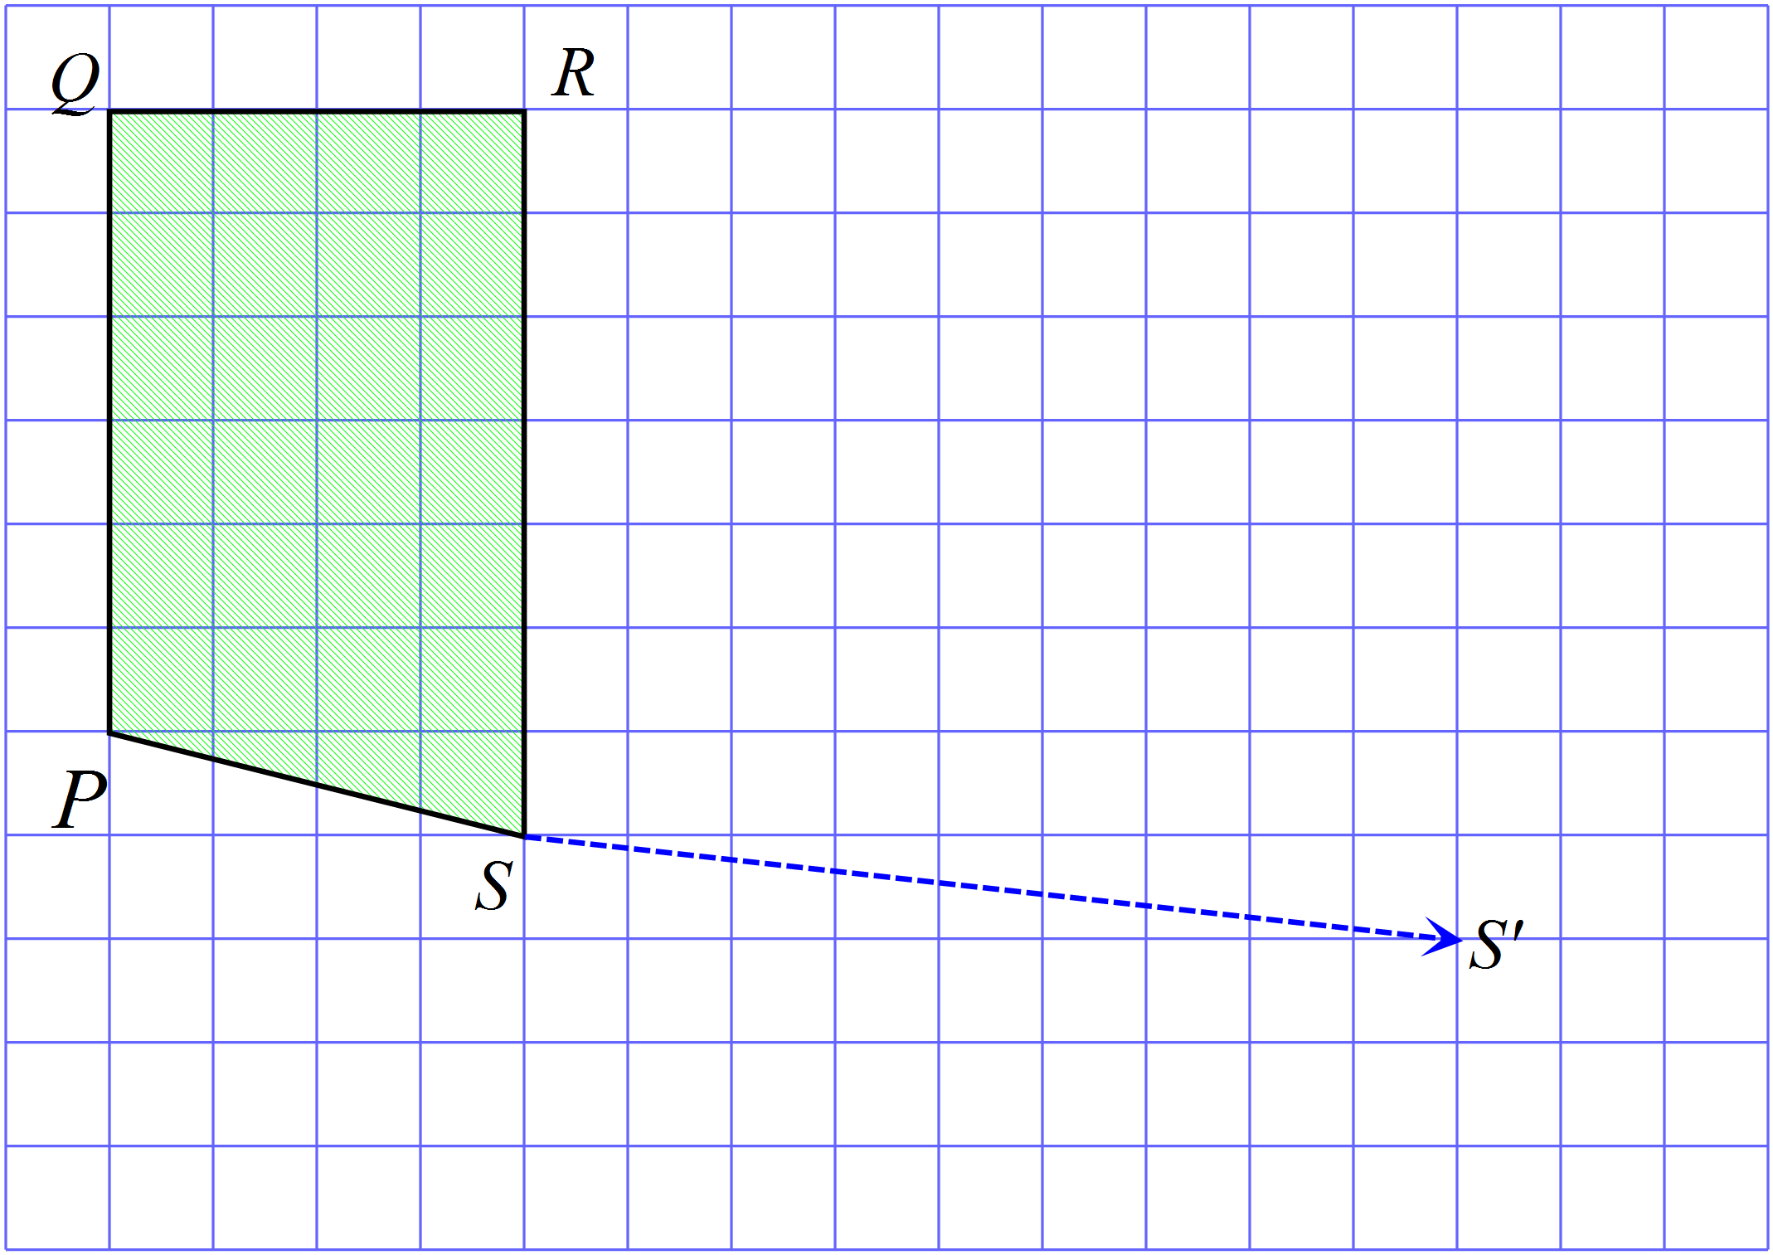

What order of rotational symmetry does the shape below have?


2 4 6 8
Use geometric instruments to draw the image after ABCD is rotated through 180º in a clockwise direction about N.
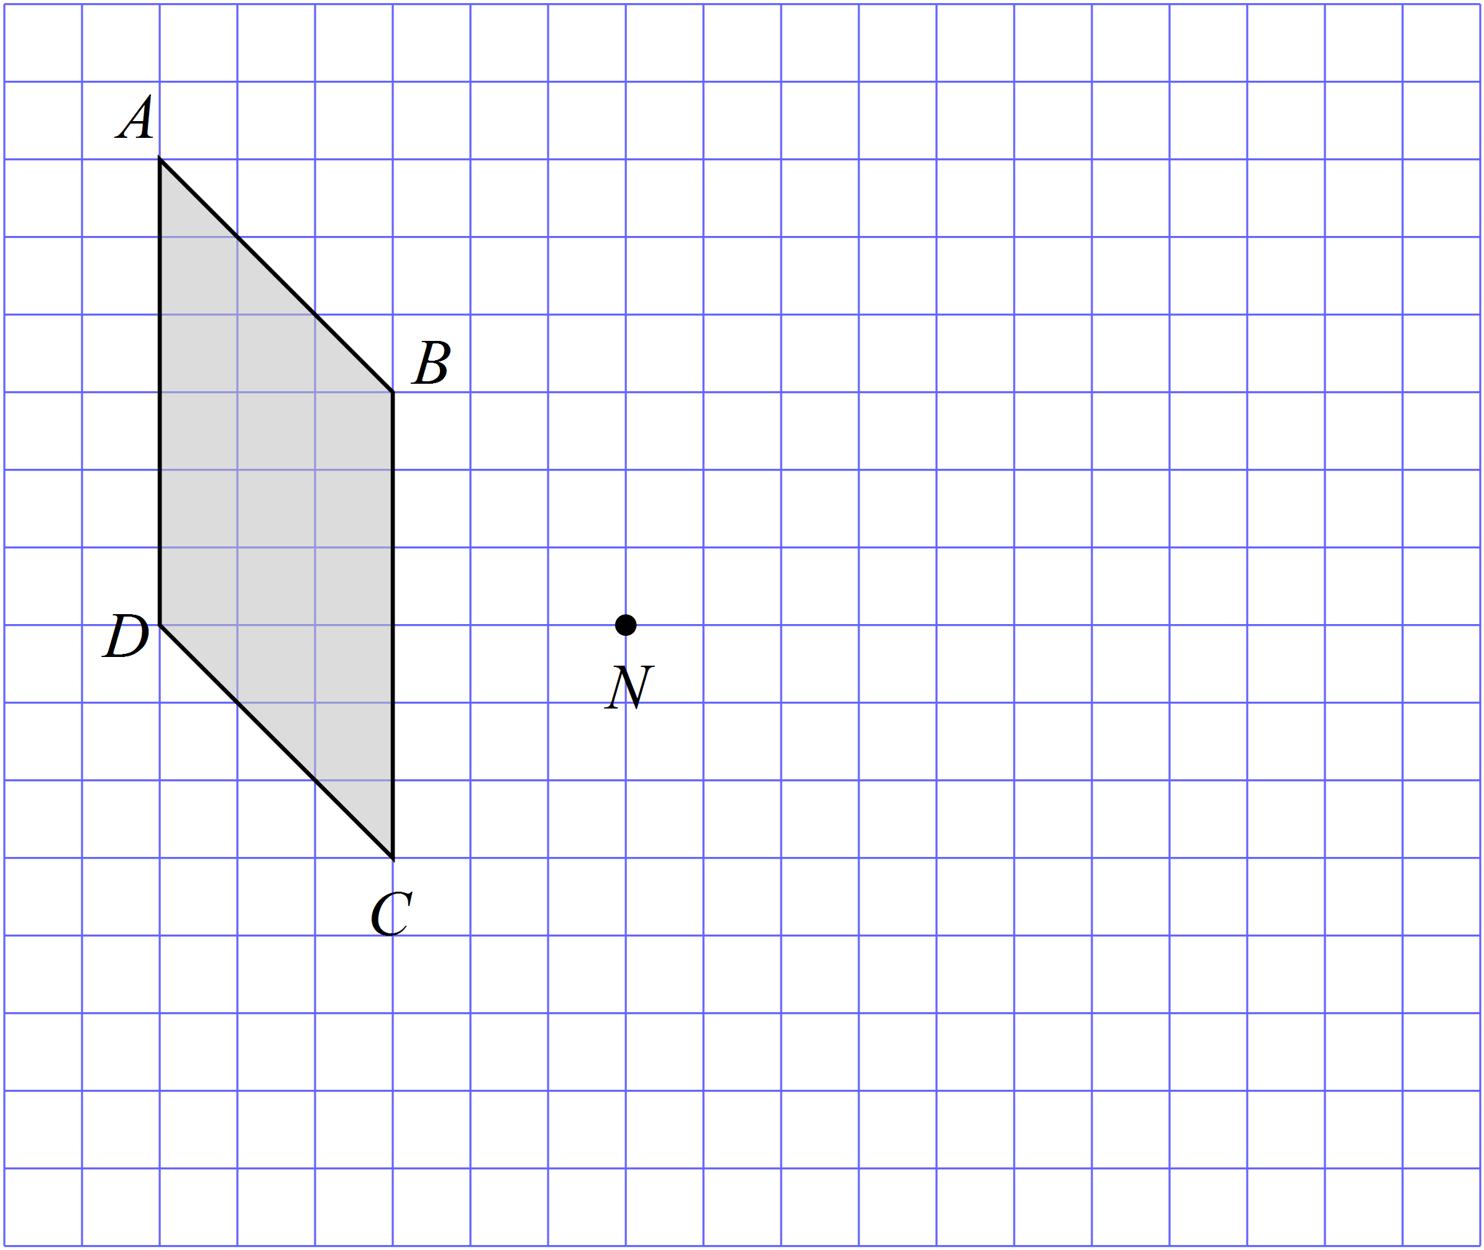

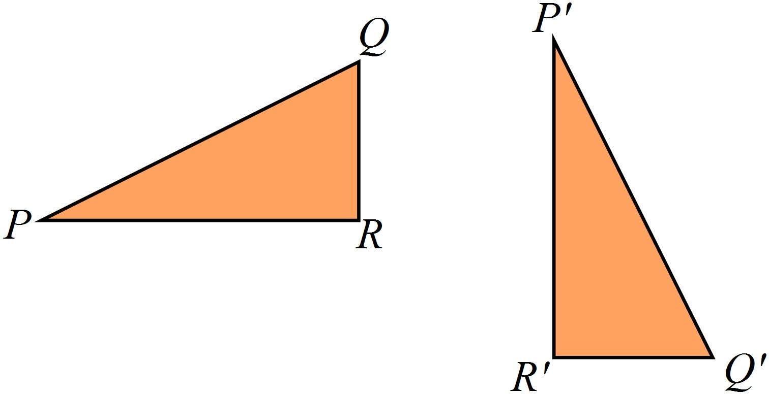The figure PQR could be transformed to the figure 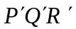 by:

Rotation through 180º.

Reflection.

Translation.

Rotation through 90º.

The triangle labelled A is reflected in the line XY.
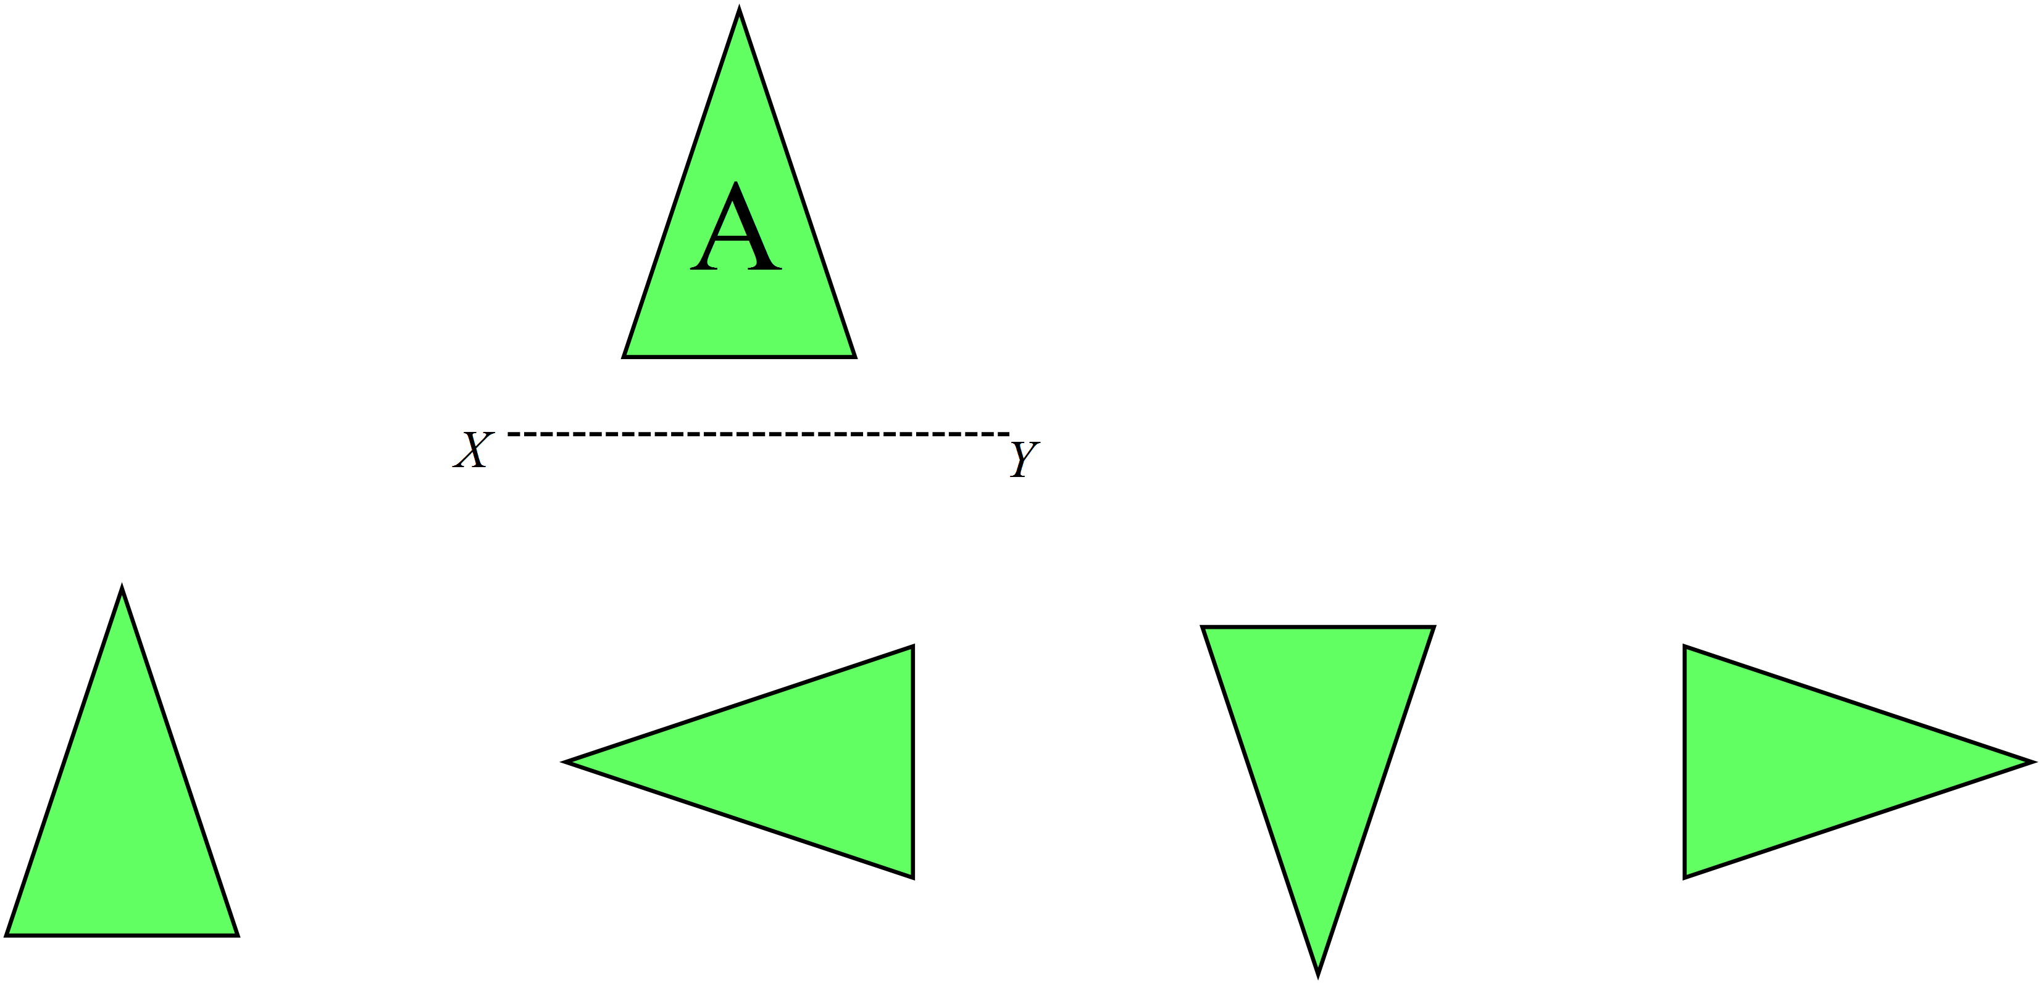
Which triangle could be the image?

Draw all of the axes of line symmetry for the shape shown.
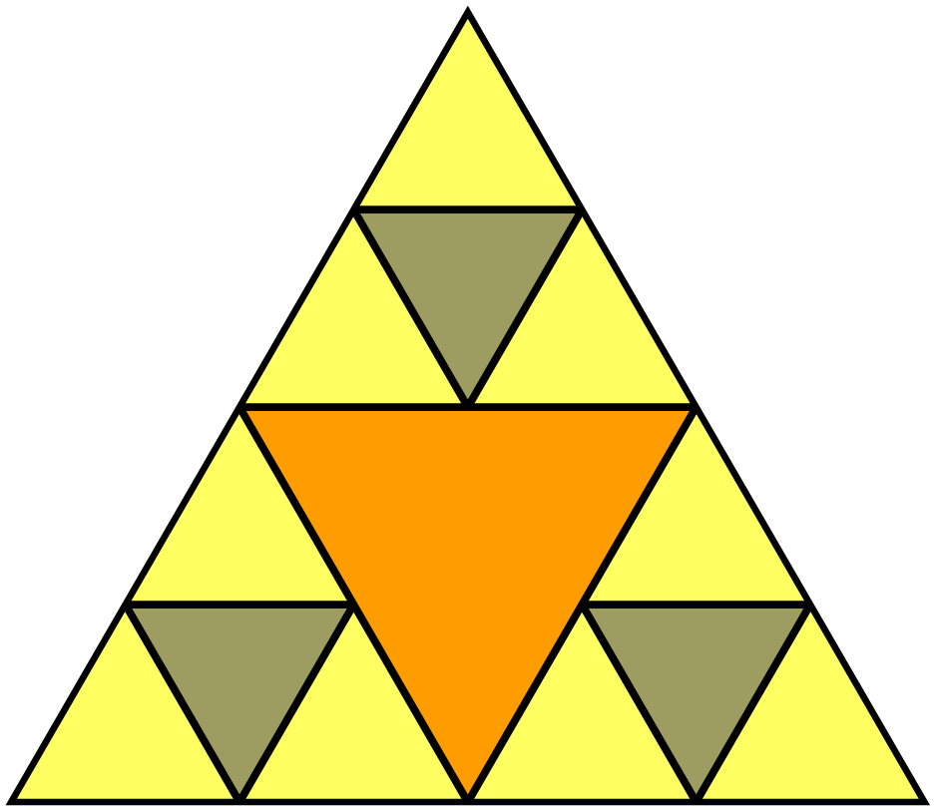

 | 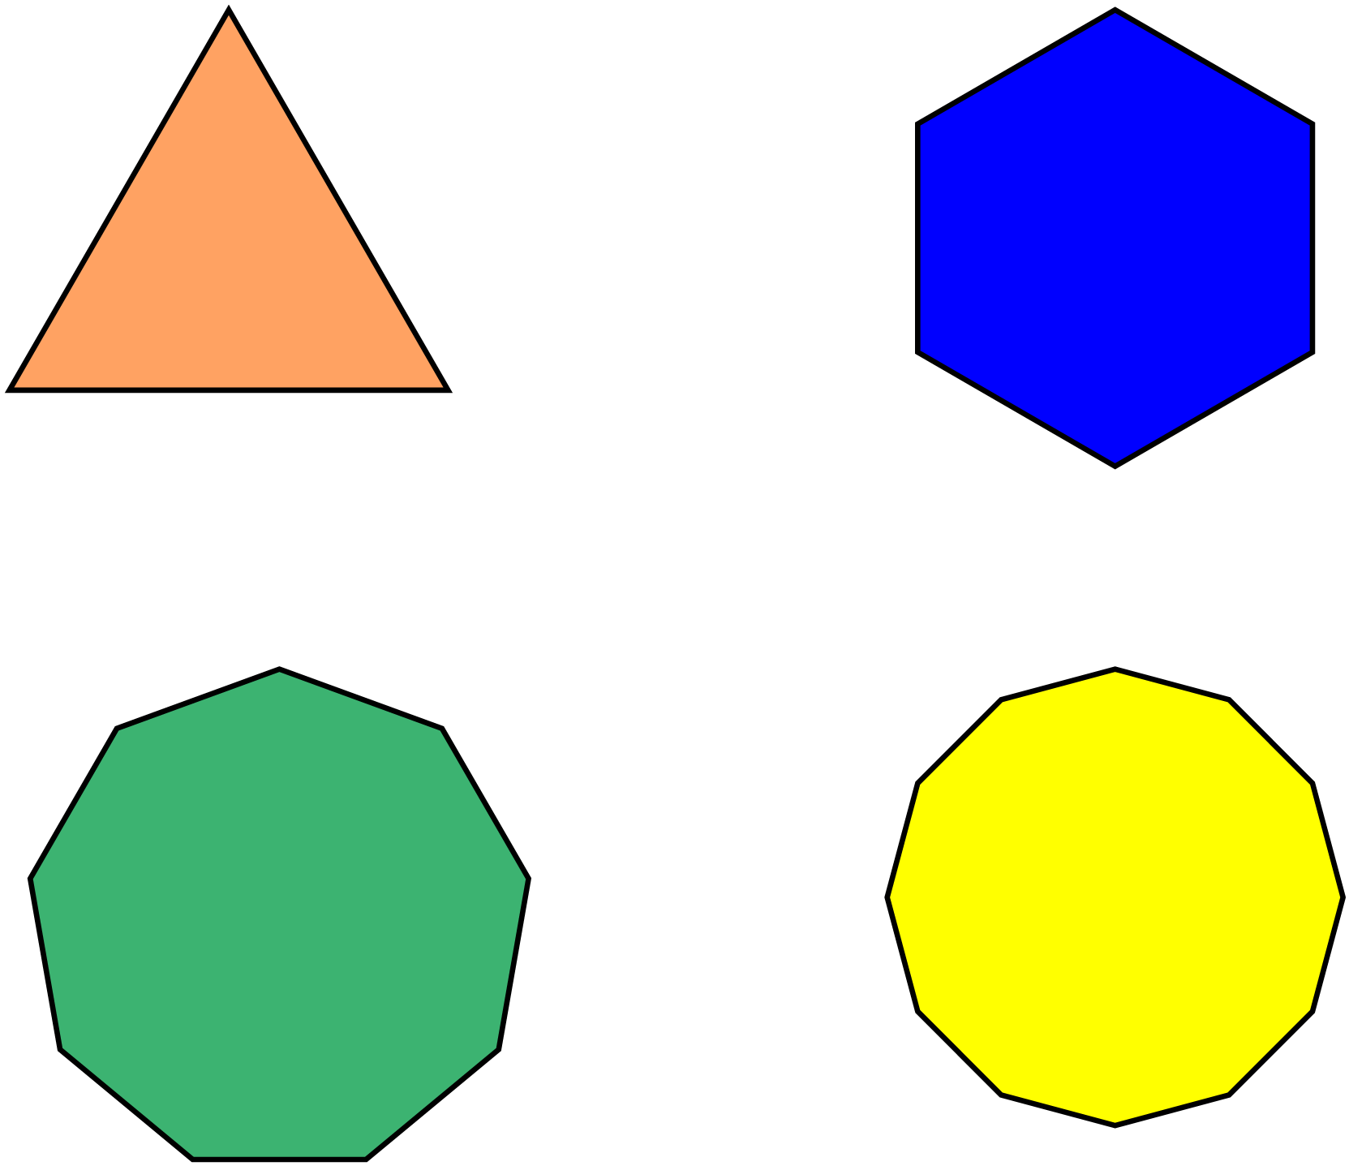Which shape has rotational symmetry of order 6?
Complete the figure given that PQ is an axis of line symmetry.
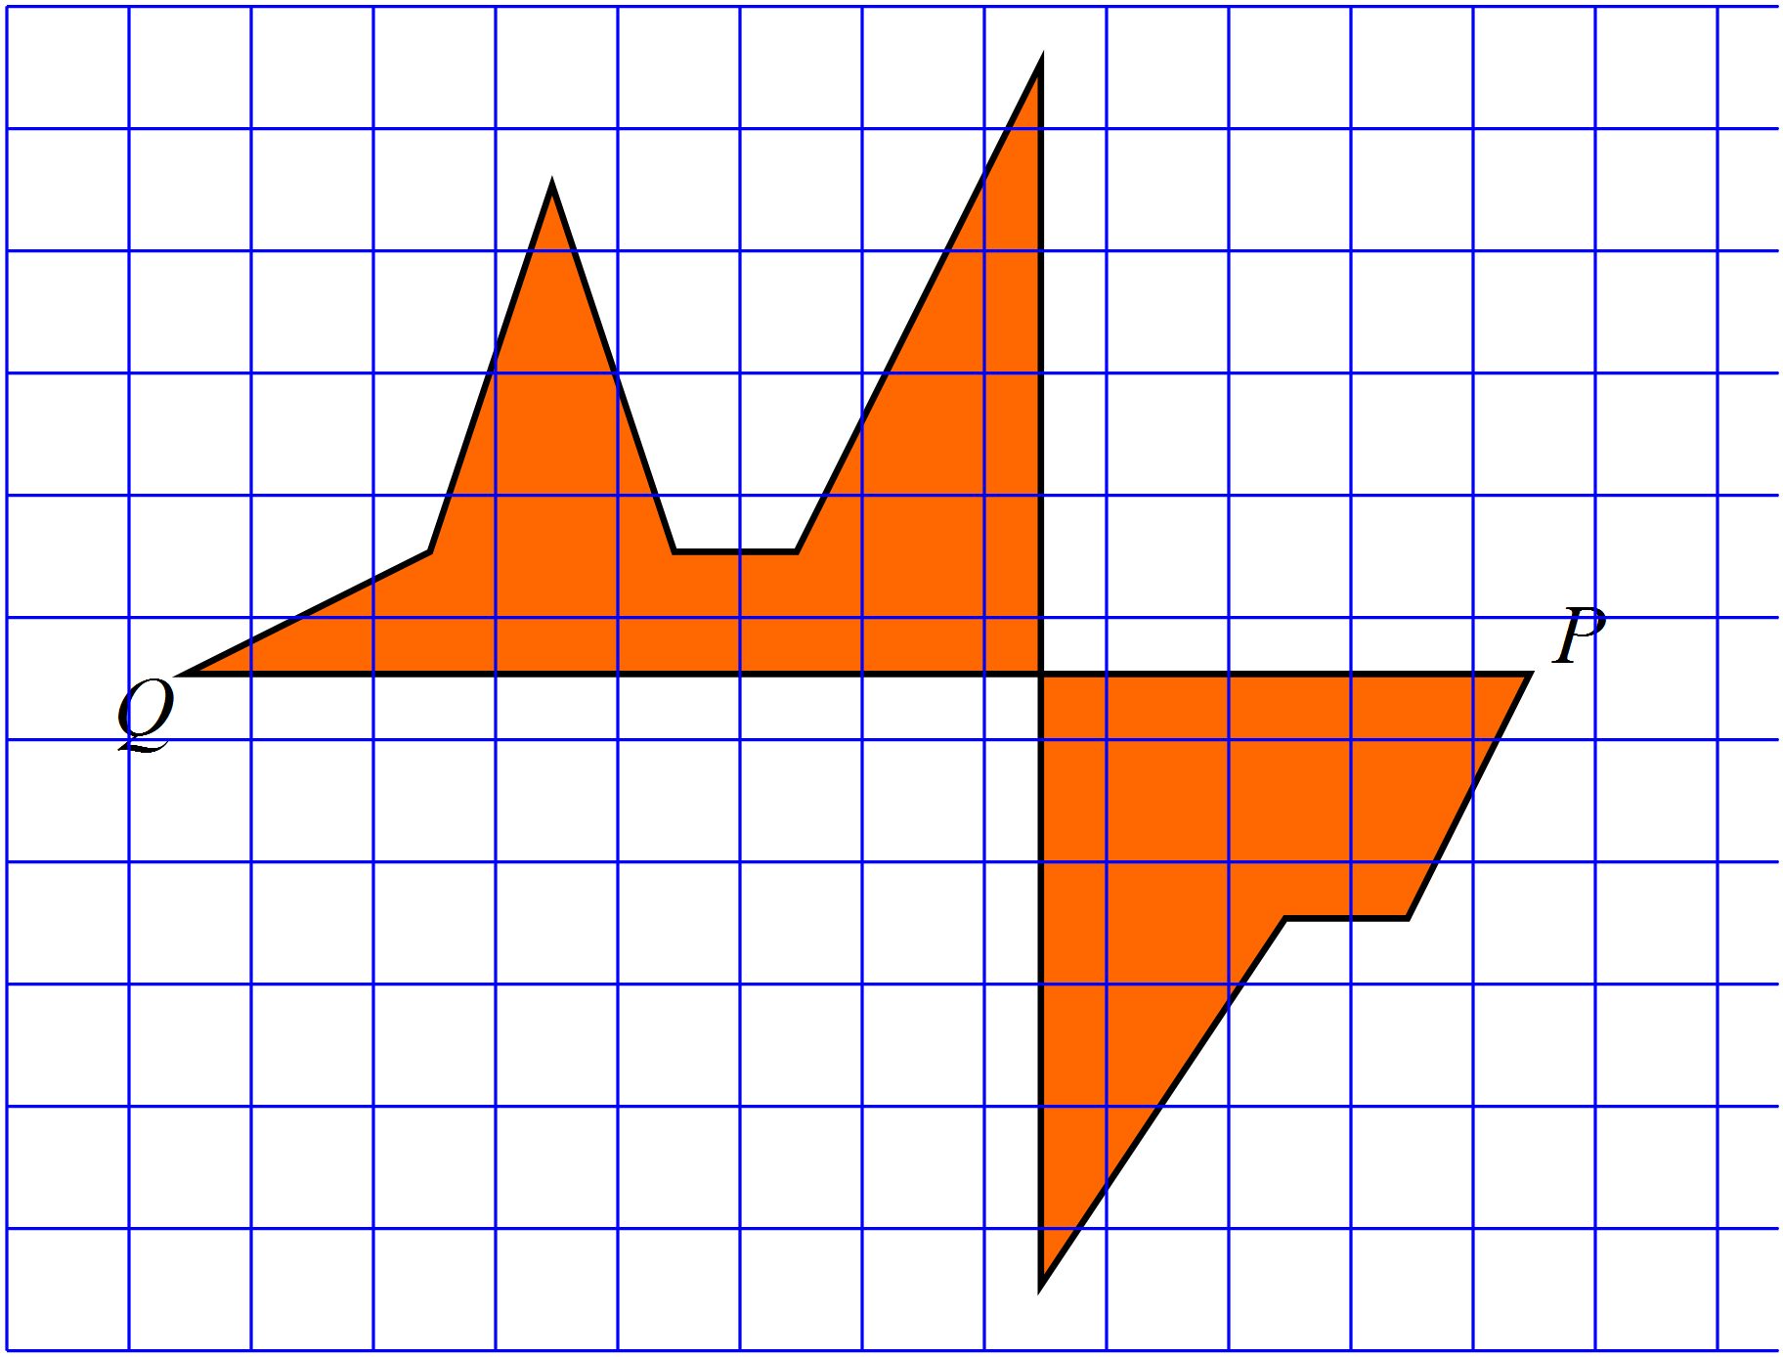

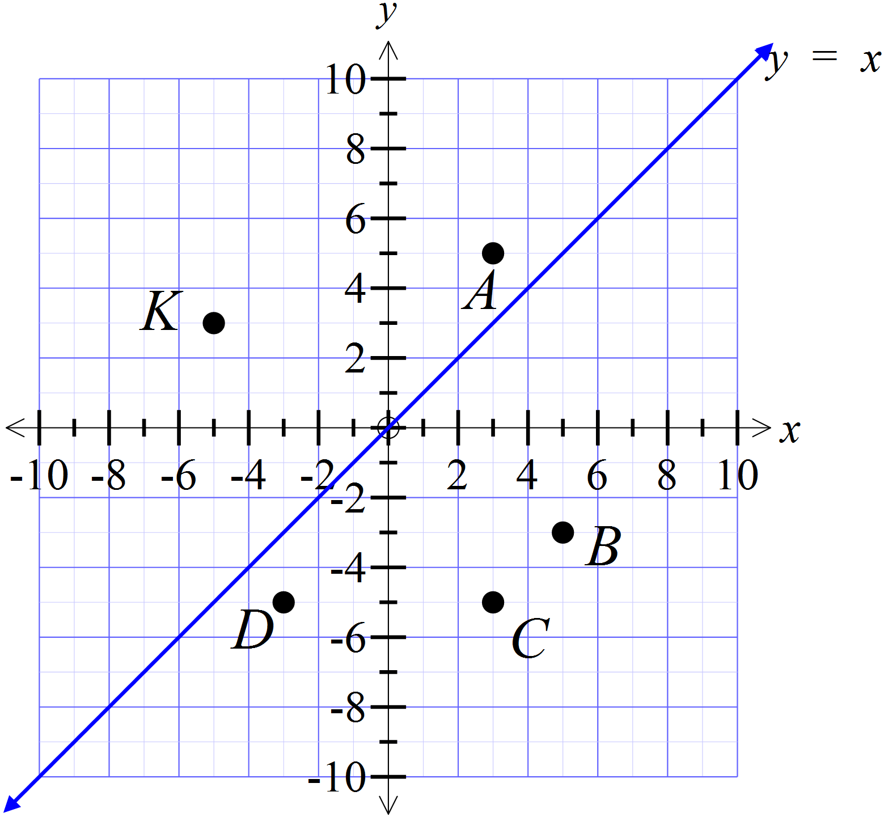The point K (-5, 3) is reflected in the line 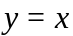 . Which point is the image after the transformation?

A (3, 5)

B (5, -3)

C (3, -5)

D (-3, -5)

 | 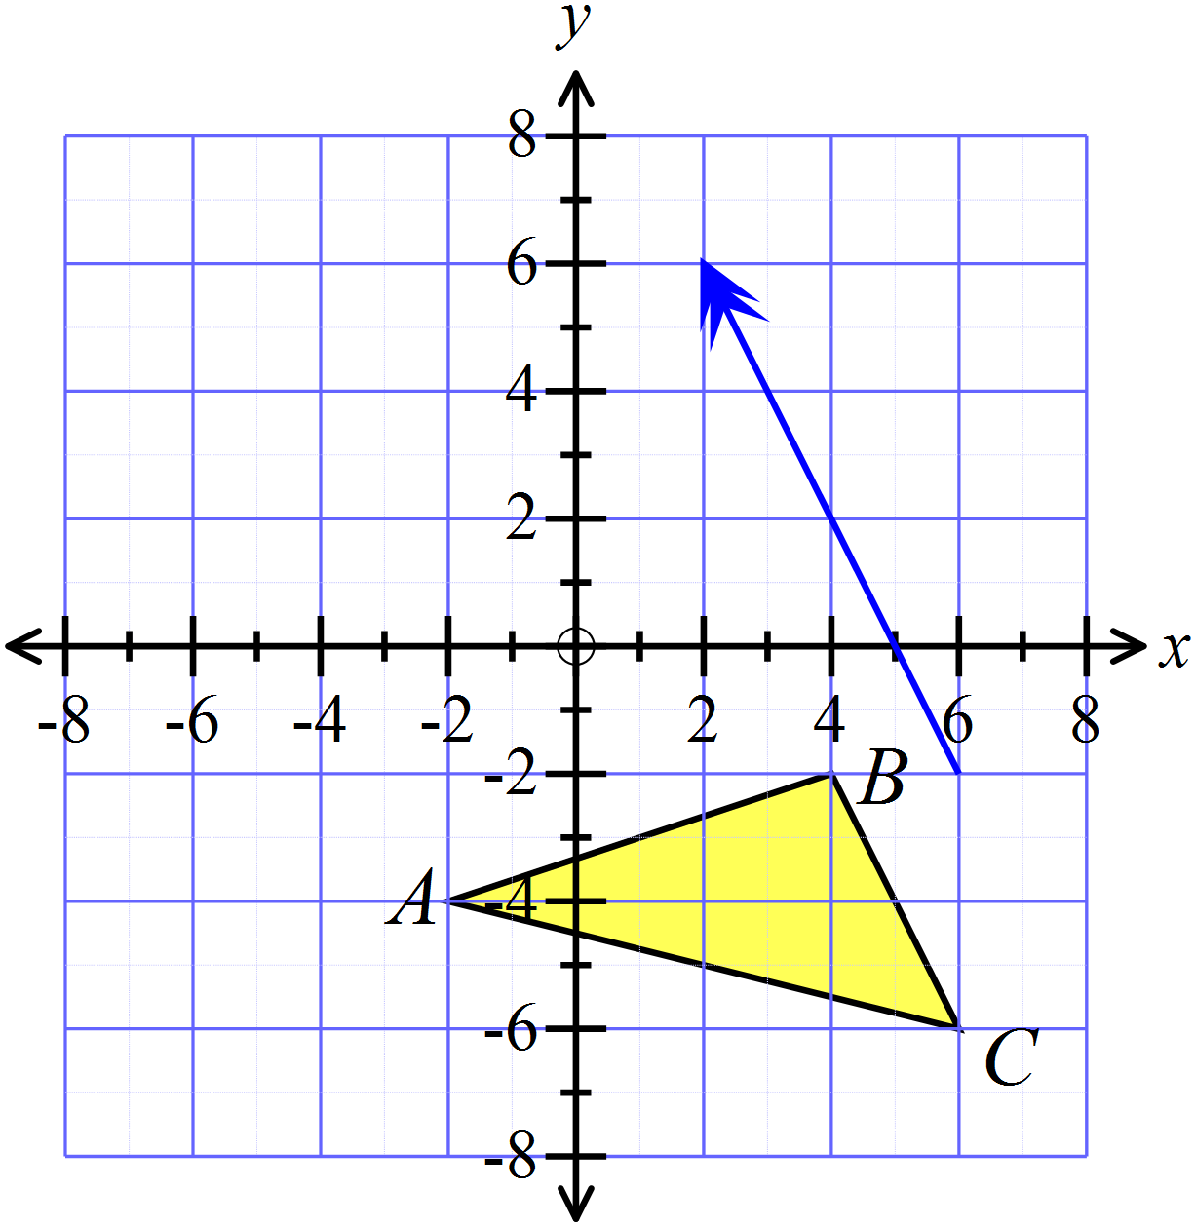Draw the position of the figure ABC after a translation in the direction and distance indicated by the arrow.
The point M (-6, -4) is rotated through 90º in an anticlockwise direction about the origin.
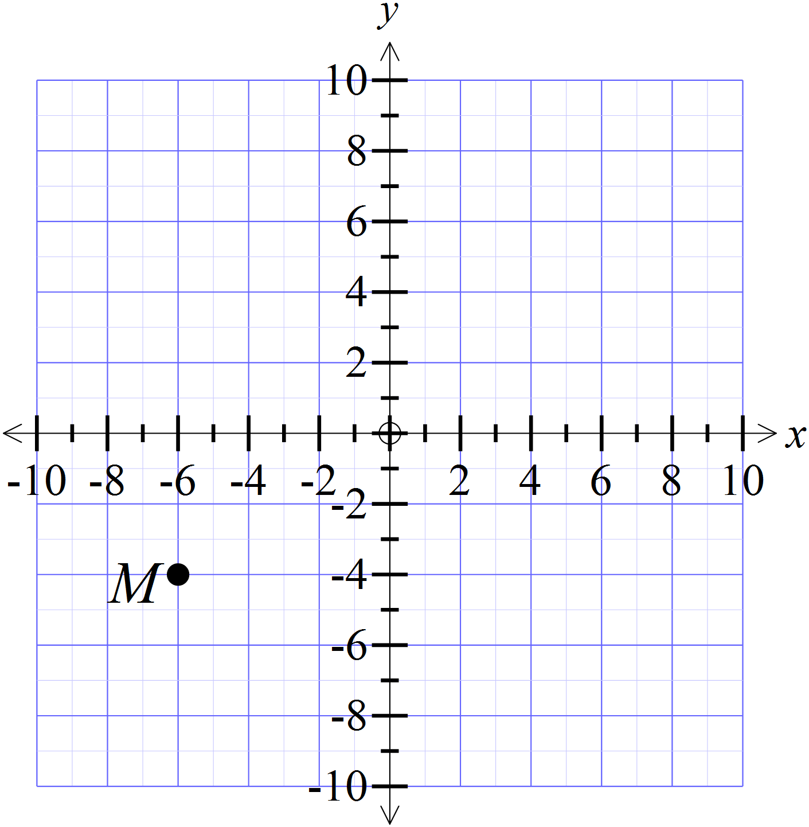Which are the coordinates of the image after the transformation?

HHlll

 | 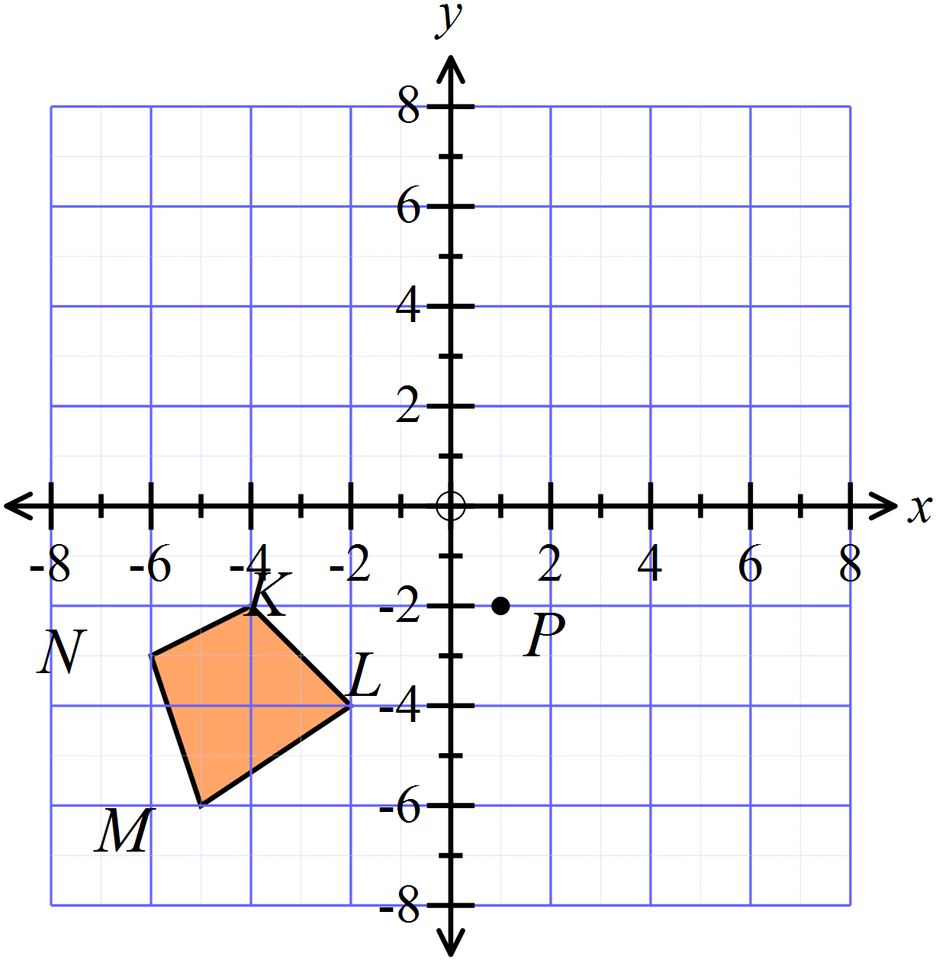Draw the position of the figure KLMN after a rotation through 180º in a clockwise direction about the point P( 1, -2)
The point T (-4, 8) is translated nine units to the right and twelve units down.
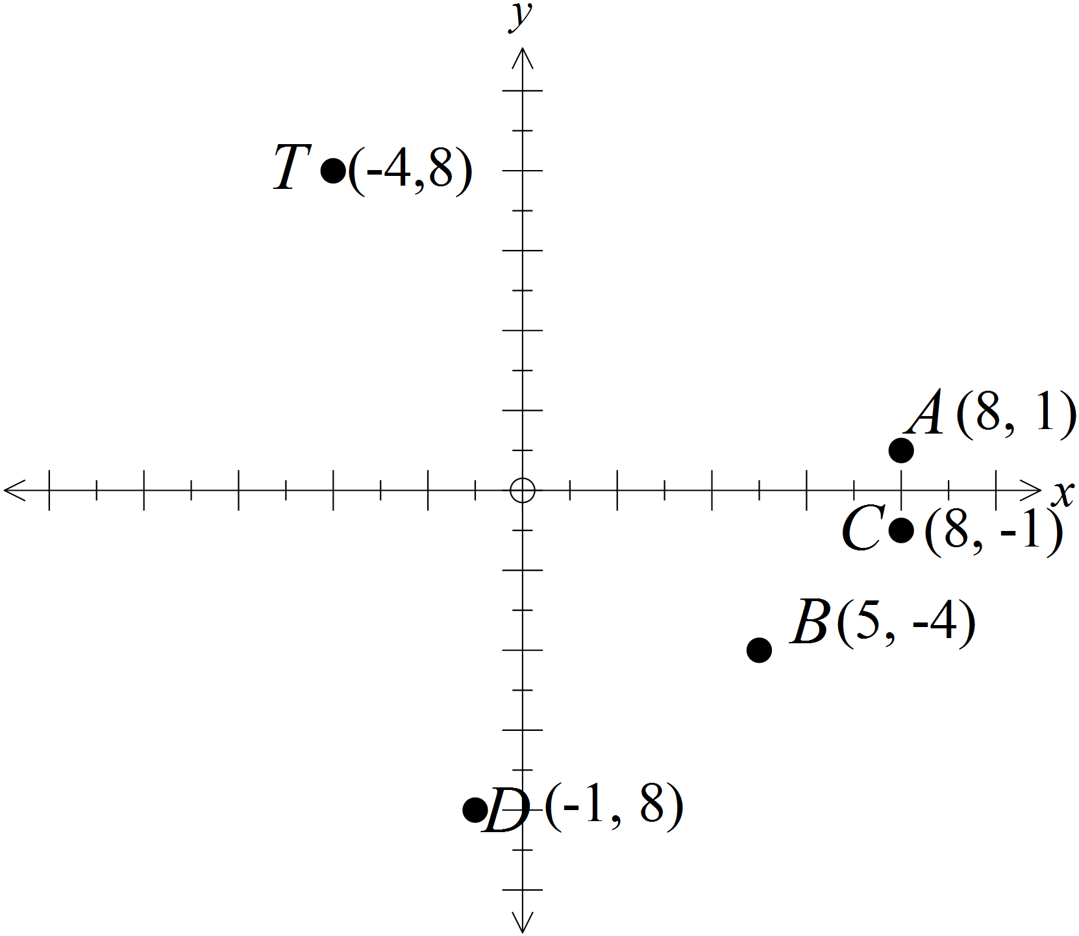Which point is the image after the transformation?

A (8, 1)

B (5, -4)

C (8, -1)

D (-1, -8)

Figure ABCD is moved to an image A’B’C’D’ by a single transformation.
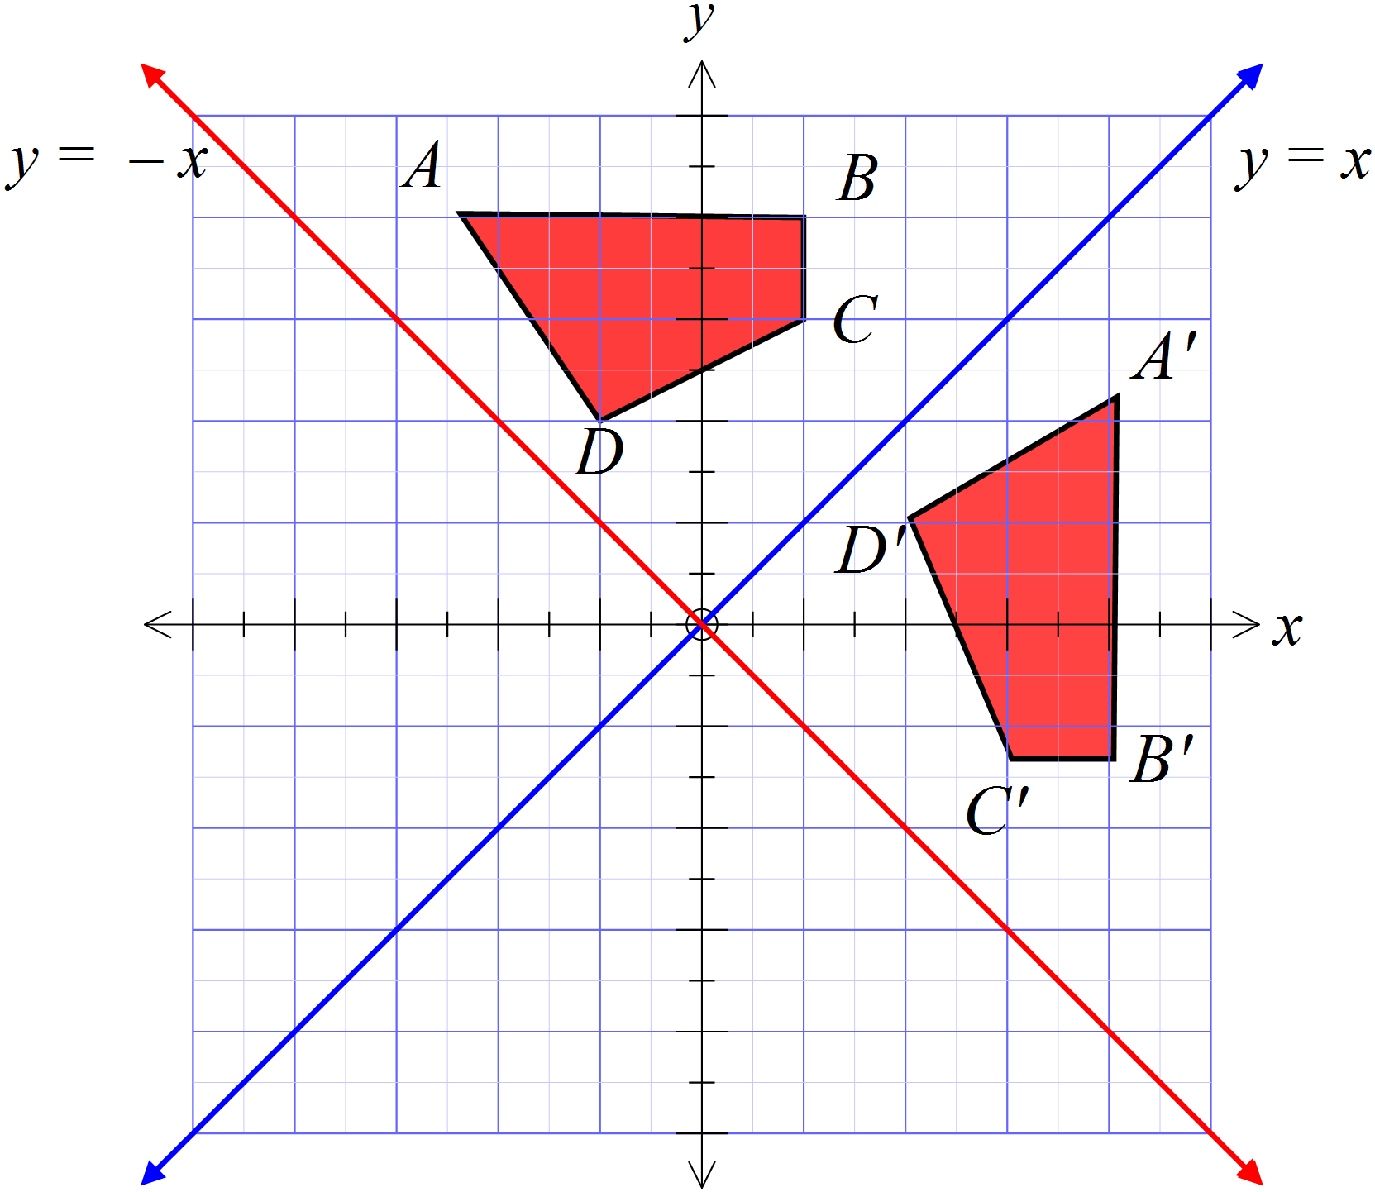What was the transformation?

A reflection in the line y = x.

A reflection in the line y = -x

An anticlockwise rotation of 90º about the origin.

A clockwise rotation of 90º about the origin.

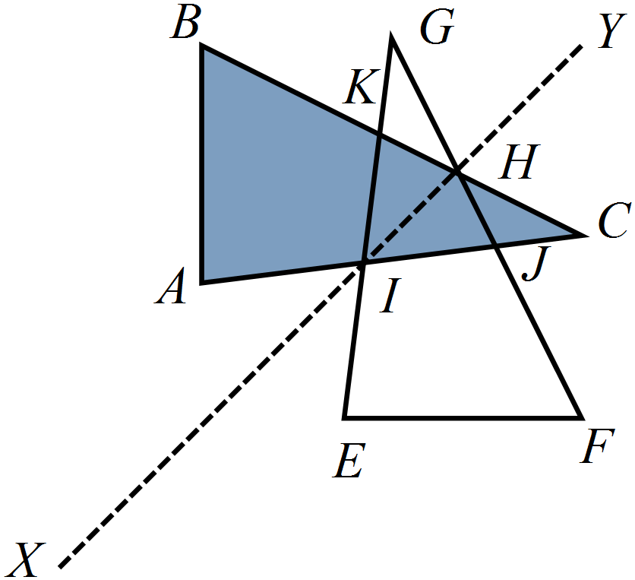The triangle ABC is reflected in the line segment XY, to give the triangle EFG.

Which is not a pair of congruent triangles?

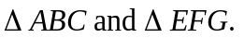

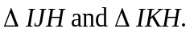

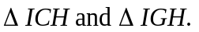

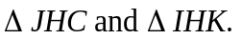

Figure UVWX is moved to an image U’V’W’X’ by a single transformation.
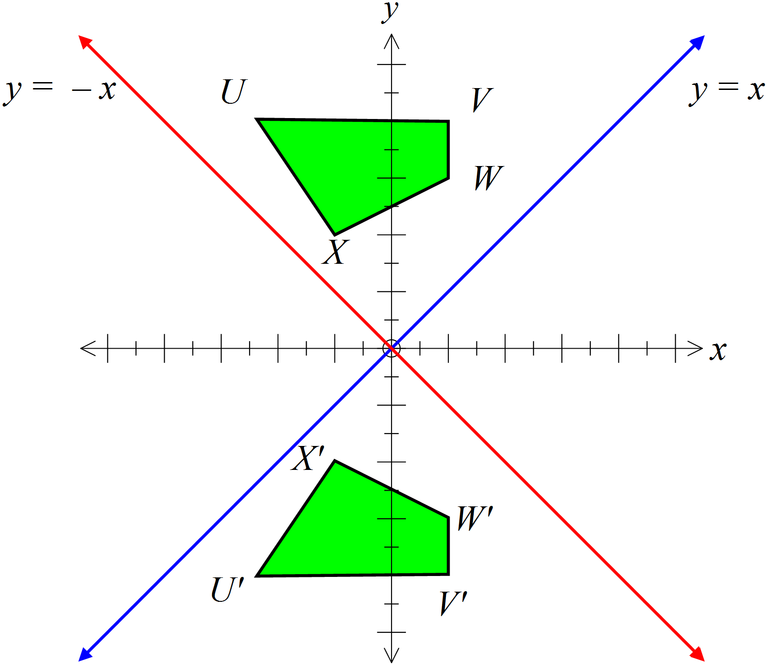What was the transformation?

A reflection in the x axis

A reflection in the y axis.

A rotation of 180º about the origin.

A translation downward along the y axis..

This geometric pattern was created by transforming congruent polygons.
Which statement is not true?

All of the polygons in the pattern are congruent.

All of the octagons in the pattern are congruent.

The pattern has line symmetry.

The pattern has rotational symmetry.

A parallelogram ABCD has both its diagonals drawn, intersecting at E.
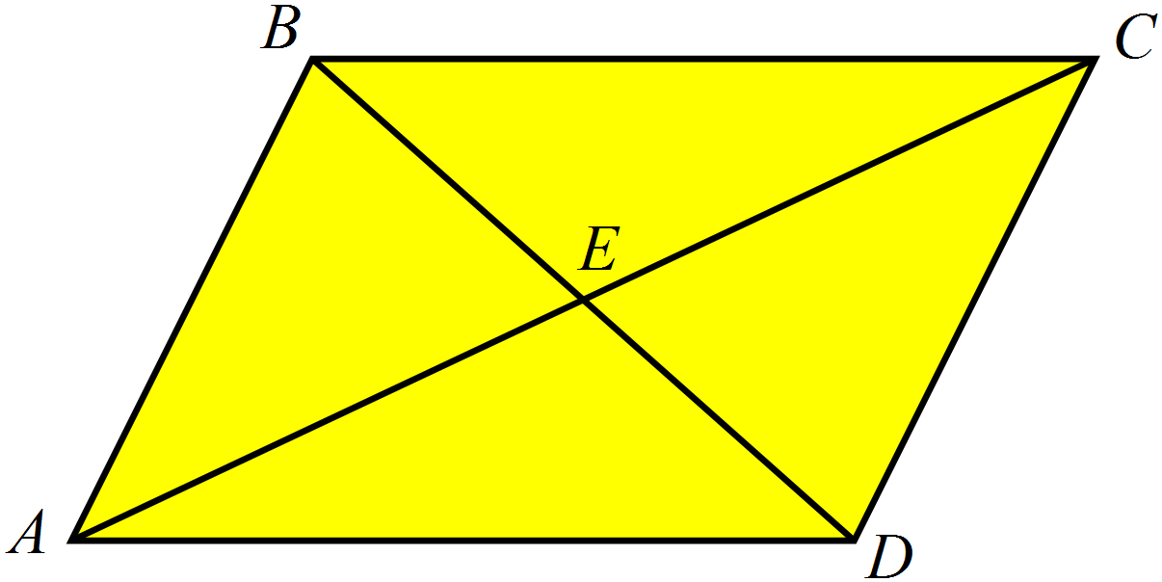
Which statement is true?

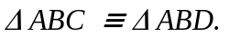

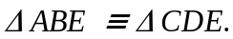

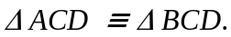

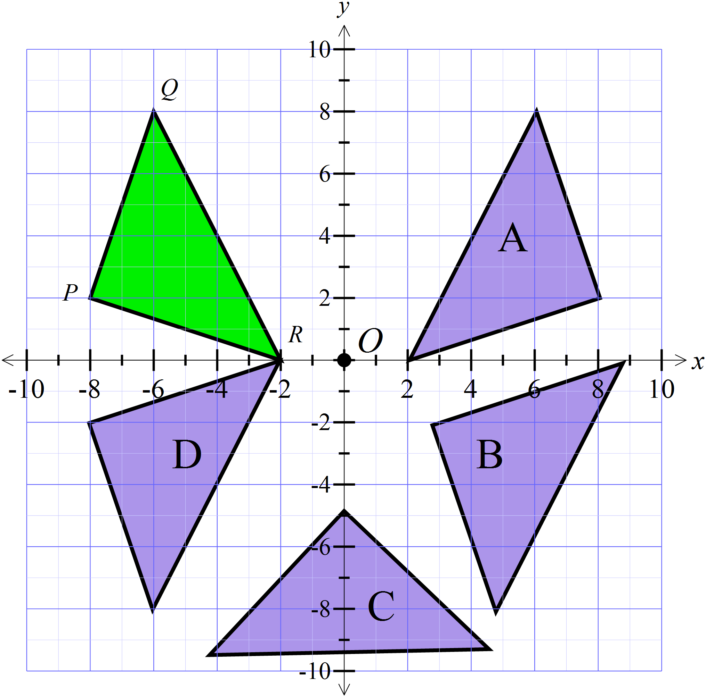PQR is reflected in the x axis and then translated to the right.

Which figure is its image?

Triangle A

Triangle B

Triangle C

Triangle D

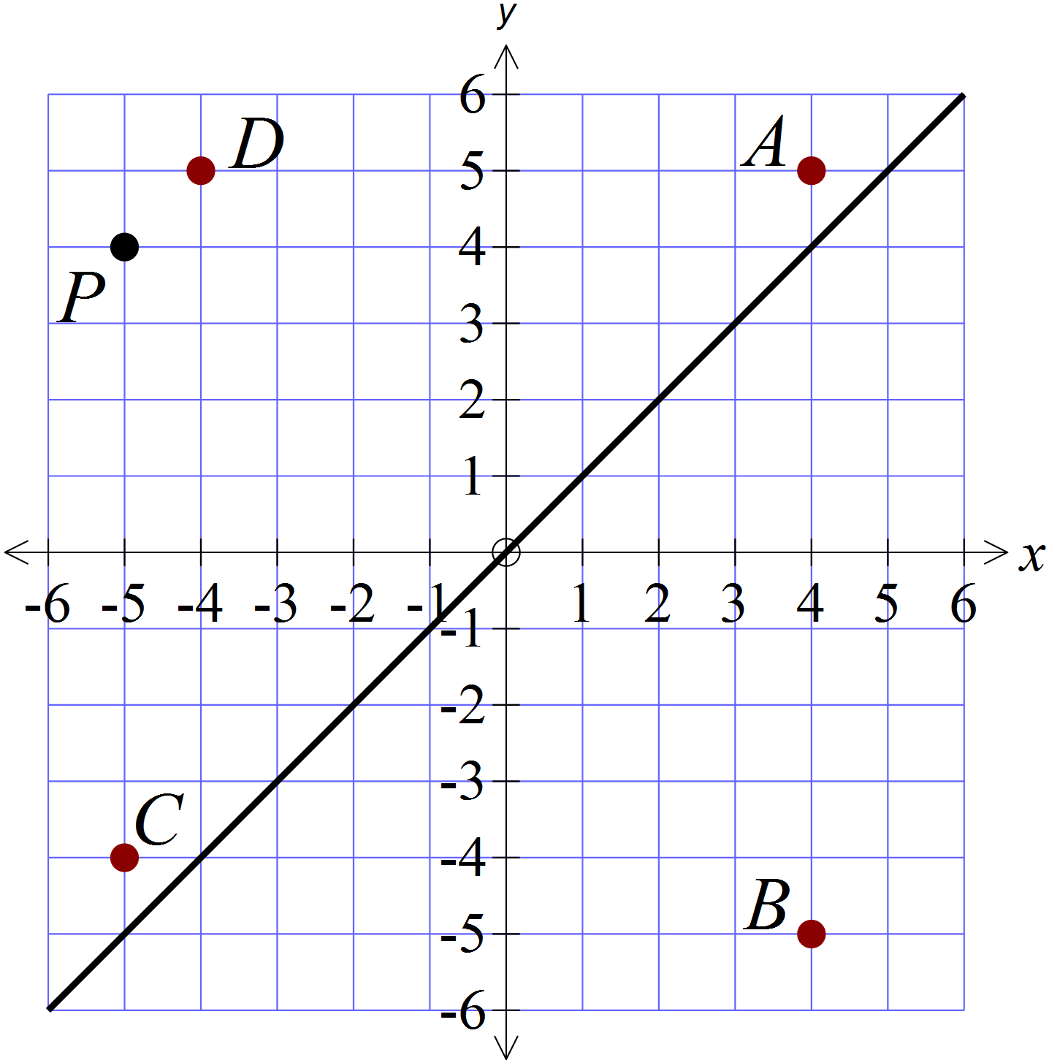The point P (-5, 4) is reflected in the line y = x and then rotated in an anticlockwise direction about the origin.
Which point is the image after these two transformations?

A (4, 5).
B (4, -5).
C (-5, -4).
D (-4, 5).

Which of the congruence tests could be used to show that 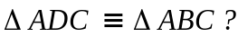
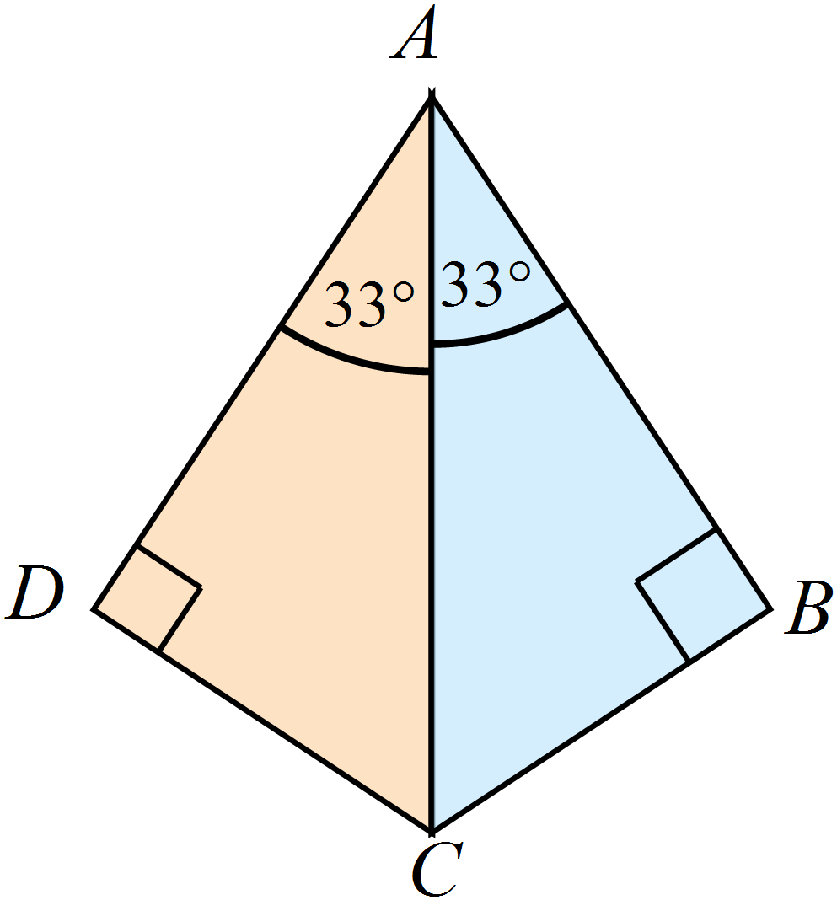

AAS RHS SAS SSS

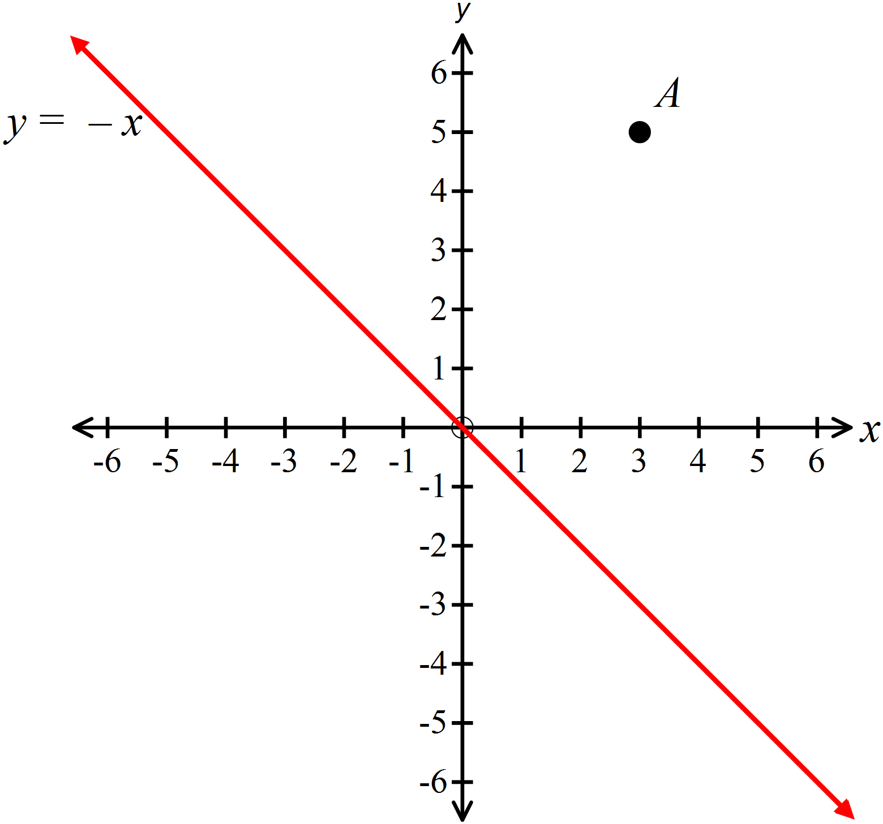The point A (3, 5) is reflected in the line y = -x and then translated 10 units to the right and 6 units upward.
Give the coordinates of the point which is the image after these transformations?

( , ) )

In the figure below, PQ = SR.
Which single additional piece of information would allow you to show that 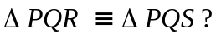
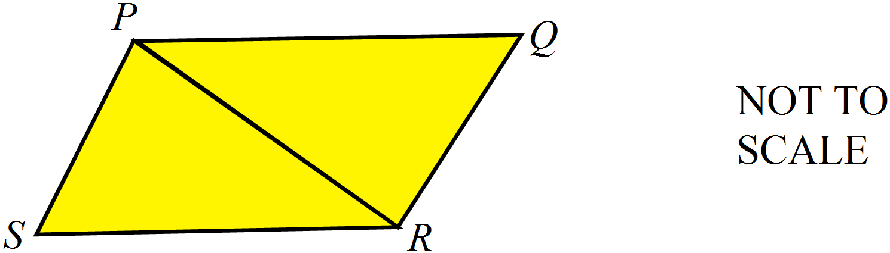

=

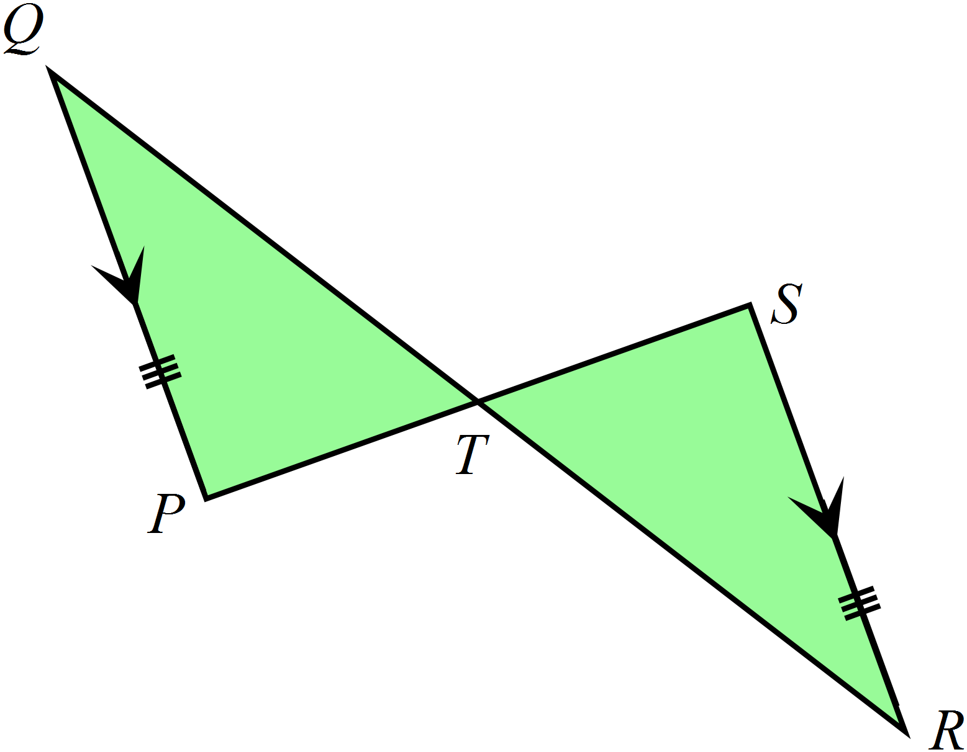QP || SR and QP = SR.
Which of the congruence tests could be used to show that 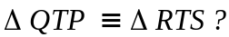

AAS
RHS
SAS
SSS

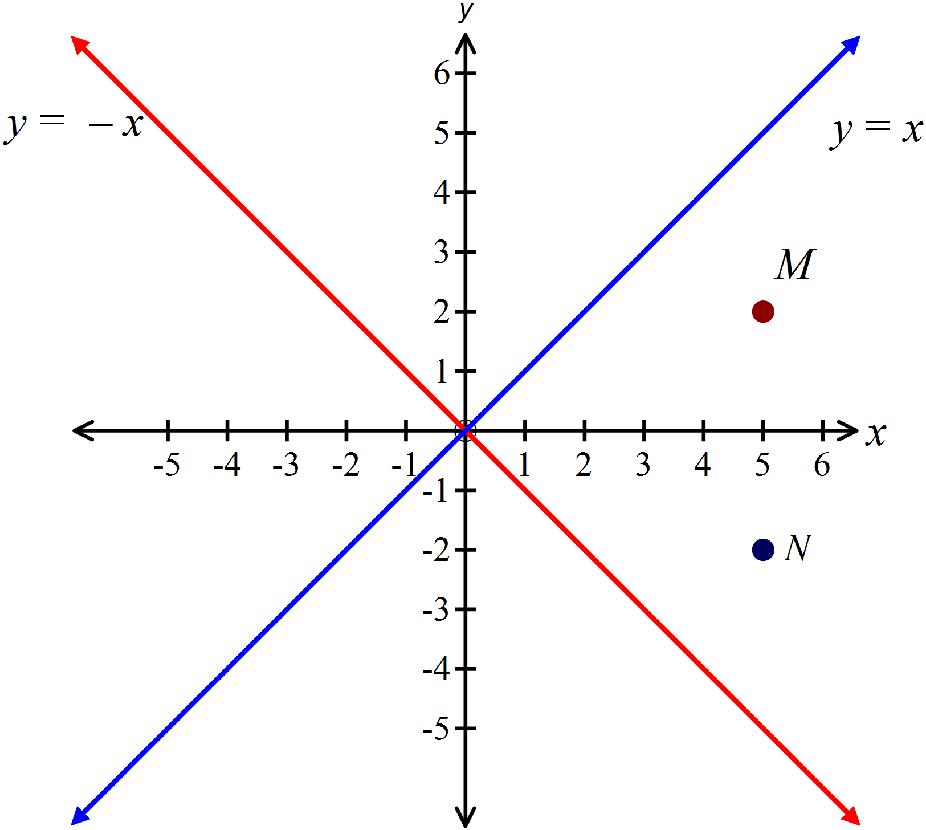The point M (5, 2) is rotated about the origin through 90º in an anticlockwise direction. What single reflection would then move the image to N(5, -2)?

)

Which of the congruence tests could be used to show that 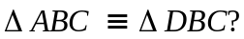.
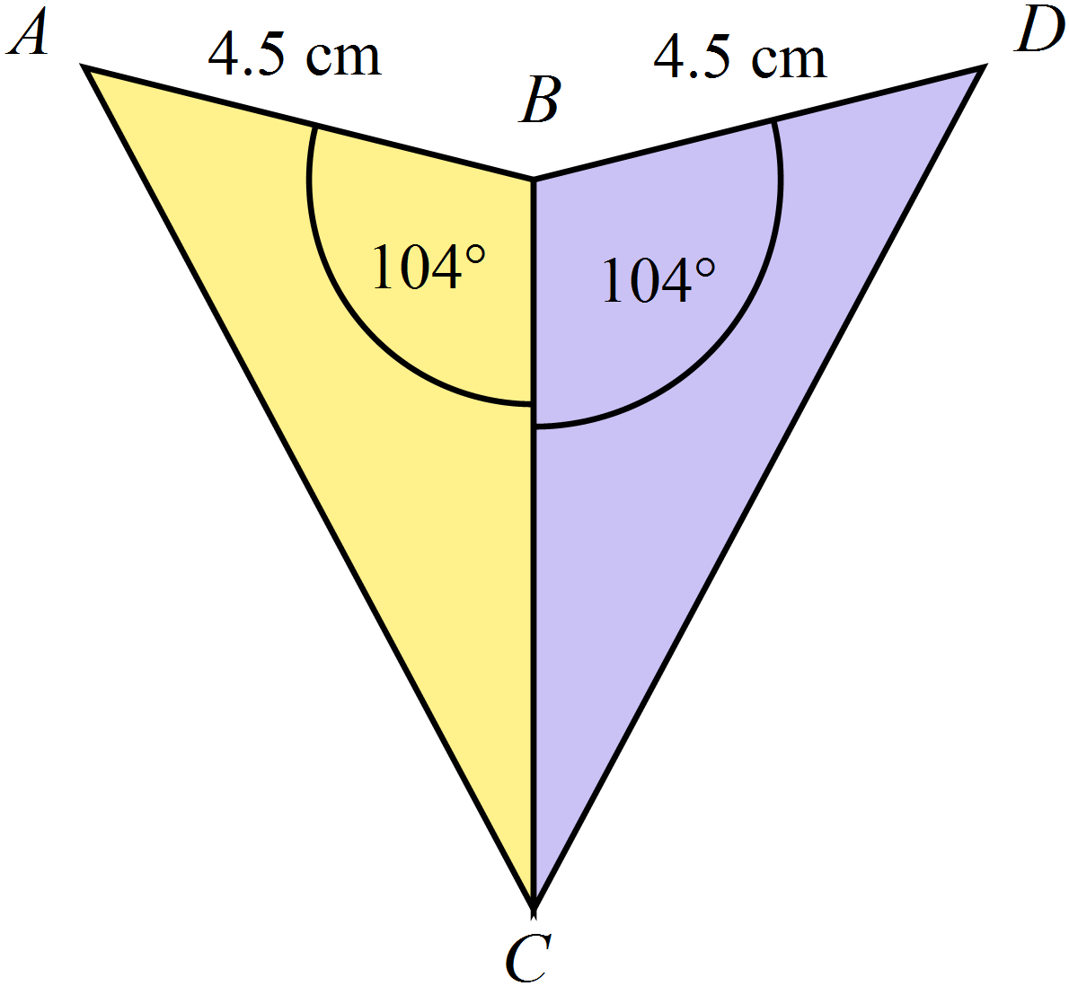

AAS RHS SAS SSS

 | 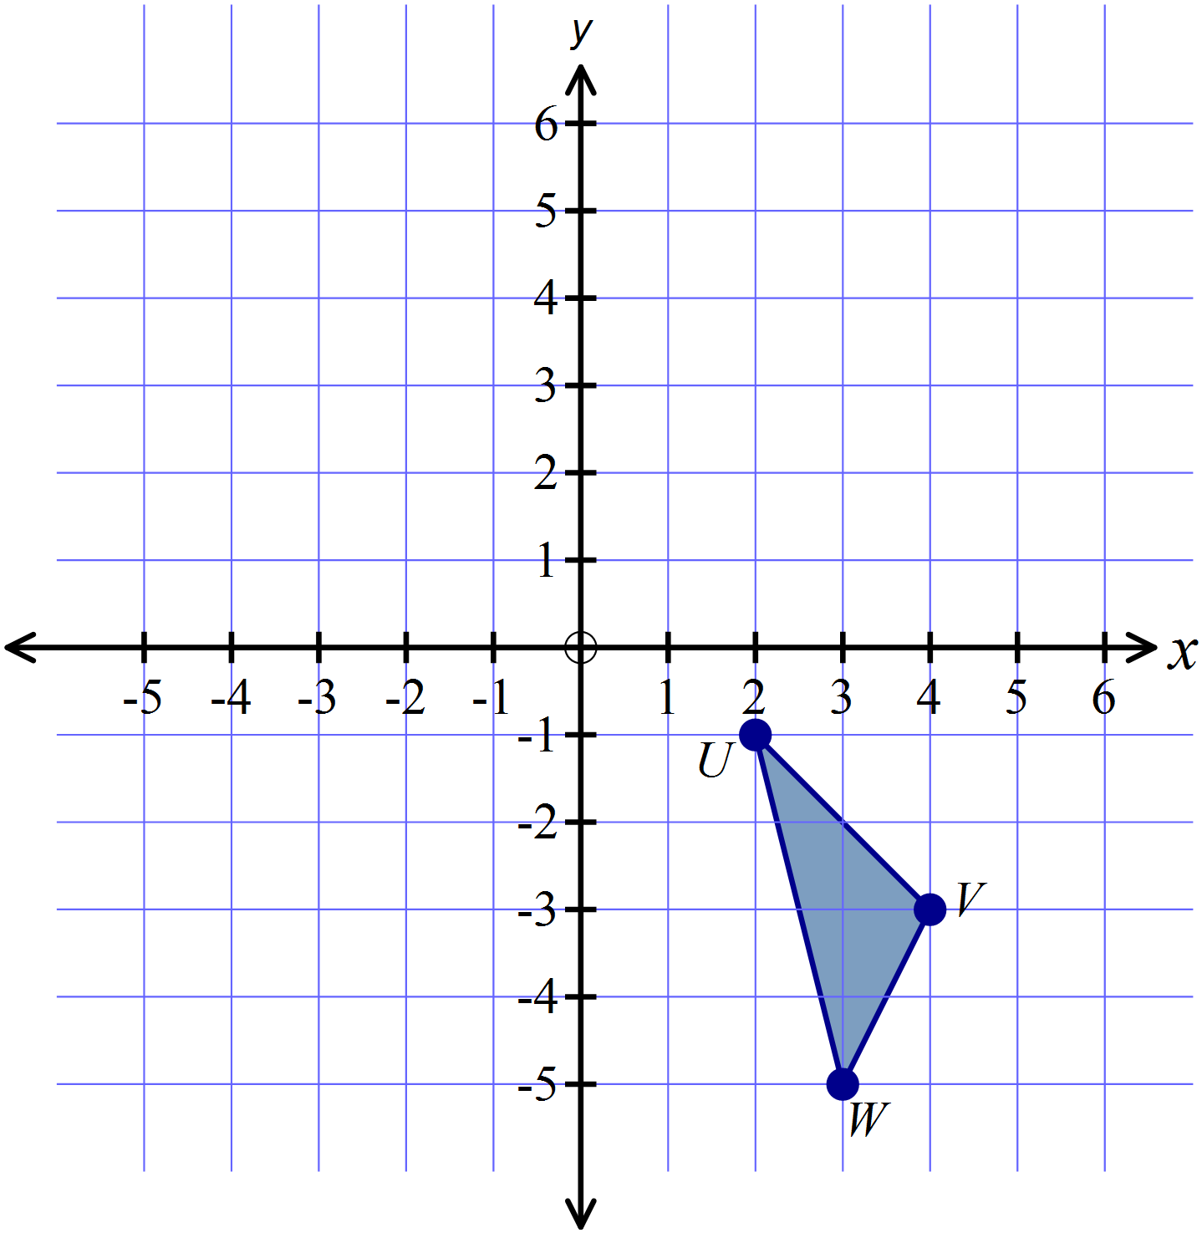The polygon UVW is rotated about the origin through 180º in a clockwise direction and then translated 8 units to the right. Draw the image U’V’W’ after these two transformations.
RX = SX, 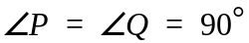and X is the midpoint of PQ.
Which of the congruence tests could be used to show that 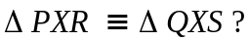

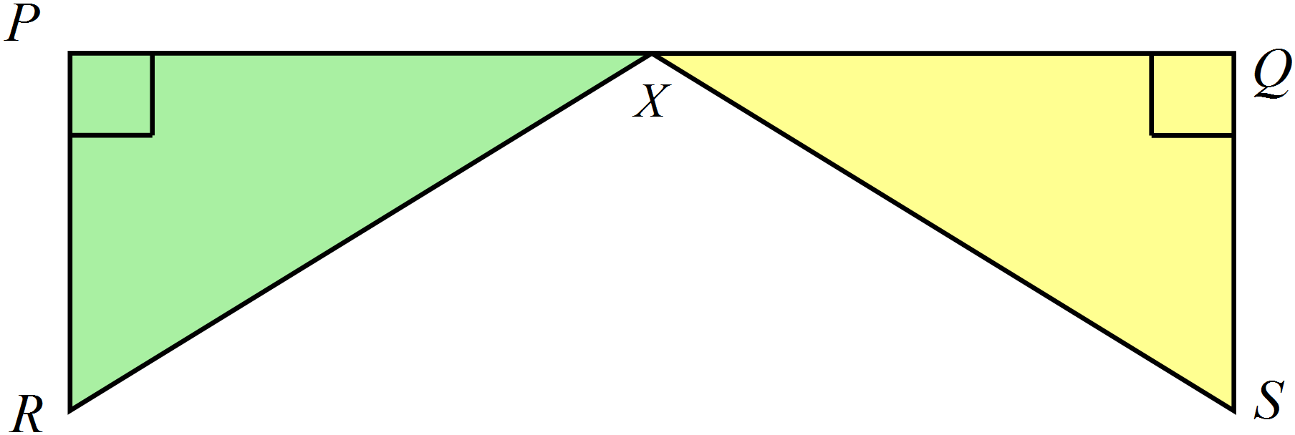

AAS RHS SAS SSS

Year  8 |  | Transformations and Congruence | Longer Answer  Section
 |  |  | Name___________________
Show all working, diagrams and answers in the spaces provided on this test paper.
Answers should be supported by relevant mathematical reasoning and/or calculations.
Marks allocated are shown beside each question.

 |  |  |  | Marks
1. | (a) Complete the diagram below so that the figure has two axes of line symmetry.  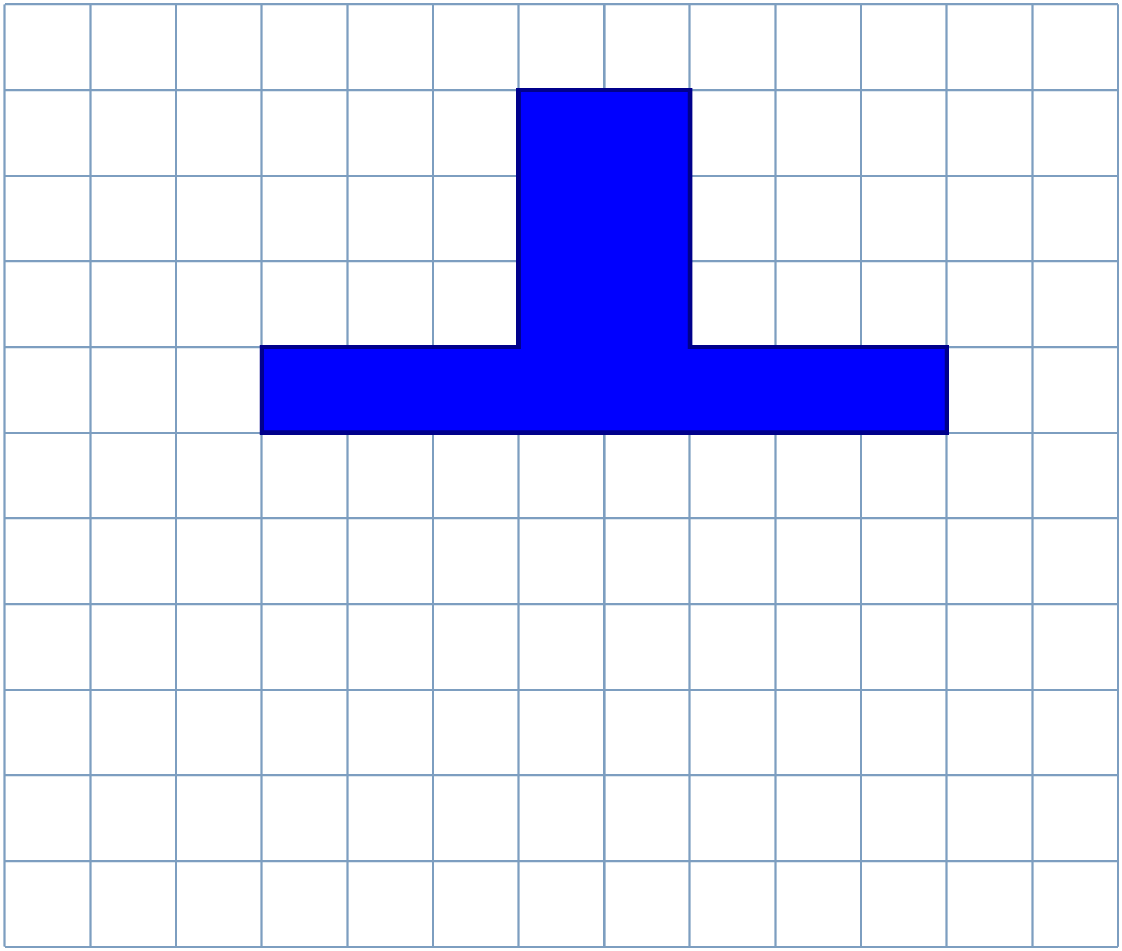 |  |  | 2
 | (b) Complete the diagram below so that the figure has rotational symmetry of order 3  .  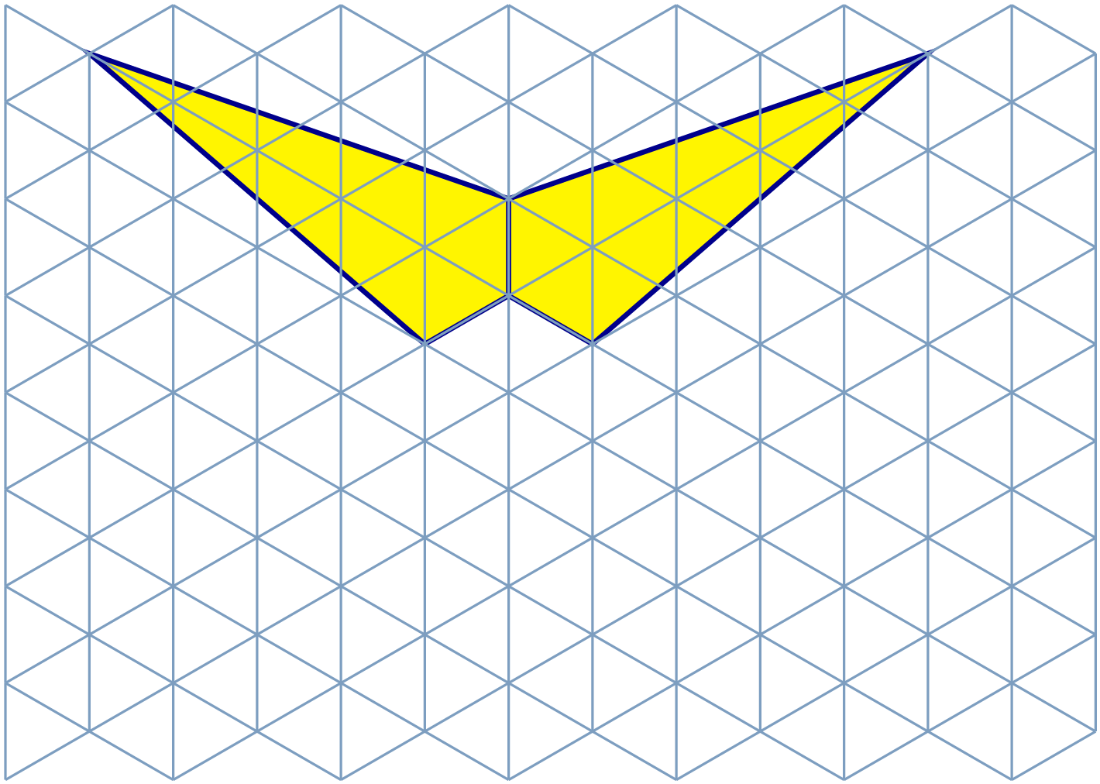 |  |  | 2
2. | (a) Draw a figure congruent to ABCD, by reflecting in the line y = x.  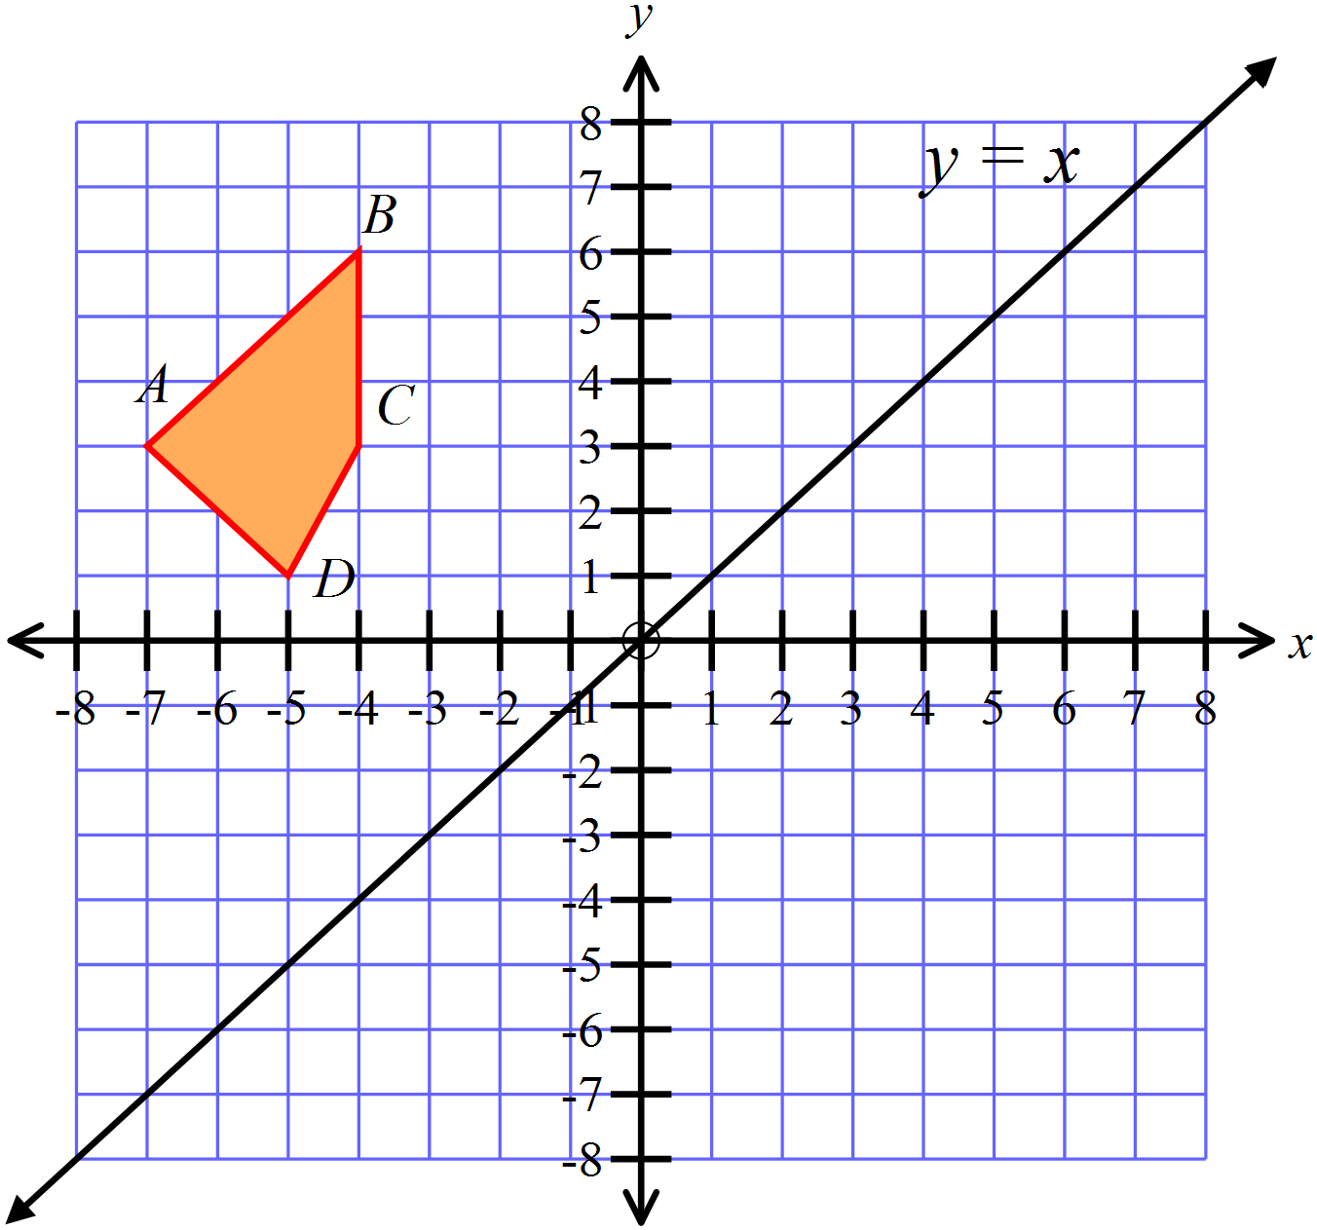 |  |  | 2
 | 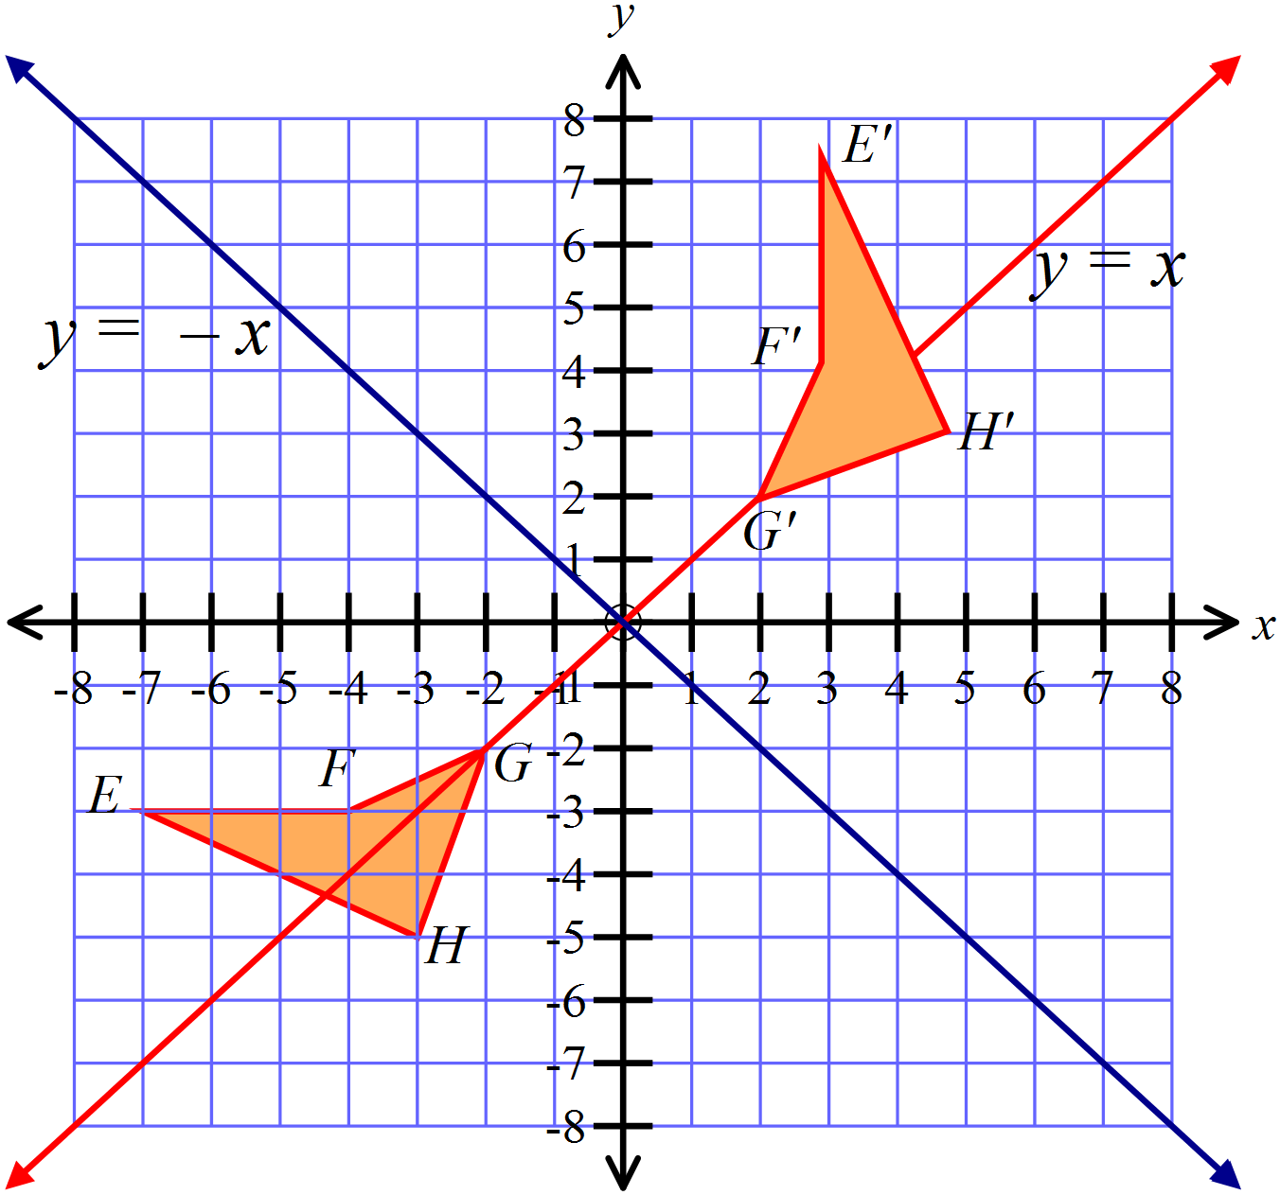(b)  Describe a single transformation that could move EFGH to its image E’F’G’H’.  ……………………………………………………………………………………..  …………………………………………………………………………………….. |  |  | 1
3. | (a) Using the information provided on the diagram below, prove that  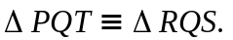  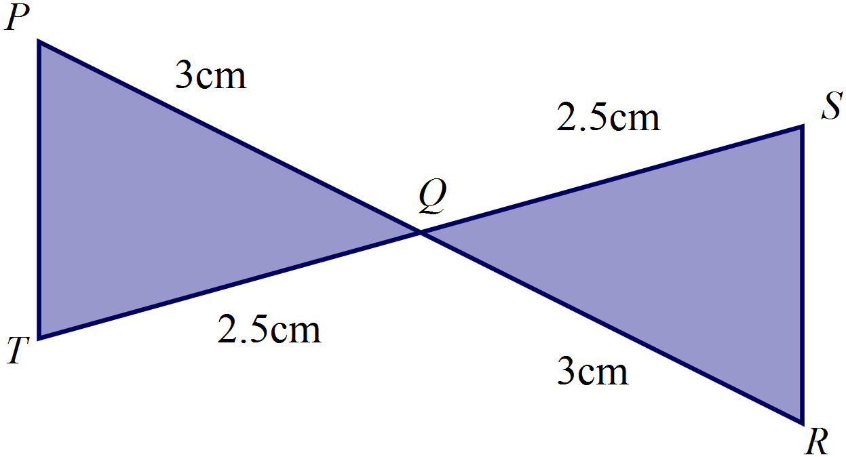  ……………………………………………………………………………………..  ……………………………………………………………………………………..  ……………………………………………………………………………………..  ……………………………………………………………………………………..  …………………………………………………………………………………….. |  |  | 3
 | (b) In the figure below, 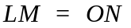 and 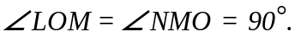  Prove that 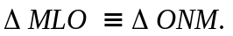  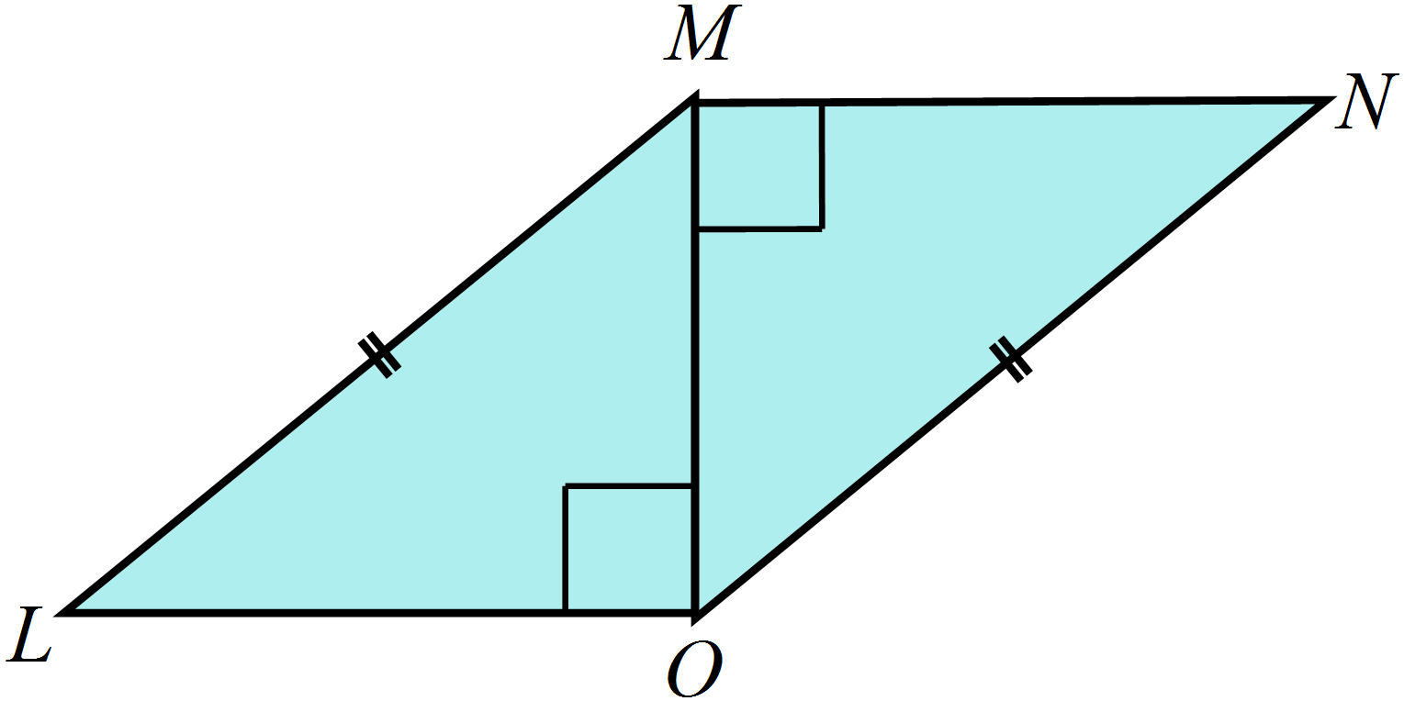  ……………………………………………………………………………………..  ……………………………………………………………………………………..  ……………………………………………………………………………………..  ……………………………………………………………………………………..  ……………………………………………………………………………………..  …………………………………………………………………………………….. |  |  | 3

Transformations and Congruence
ANSWERS
Non Calculator Section ( 1 mark each)

Working and Answers
Use geometric instruments to draw the image after EFGH is reflected in the line AB.
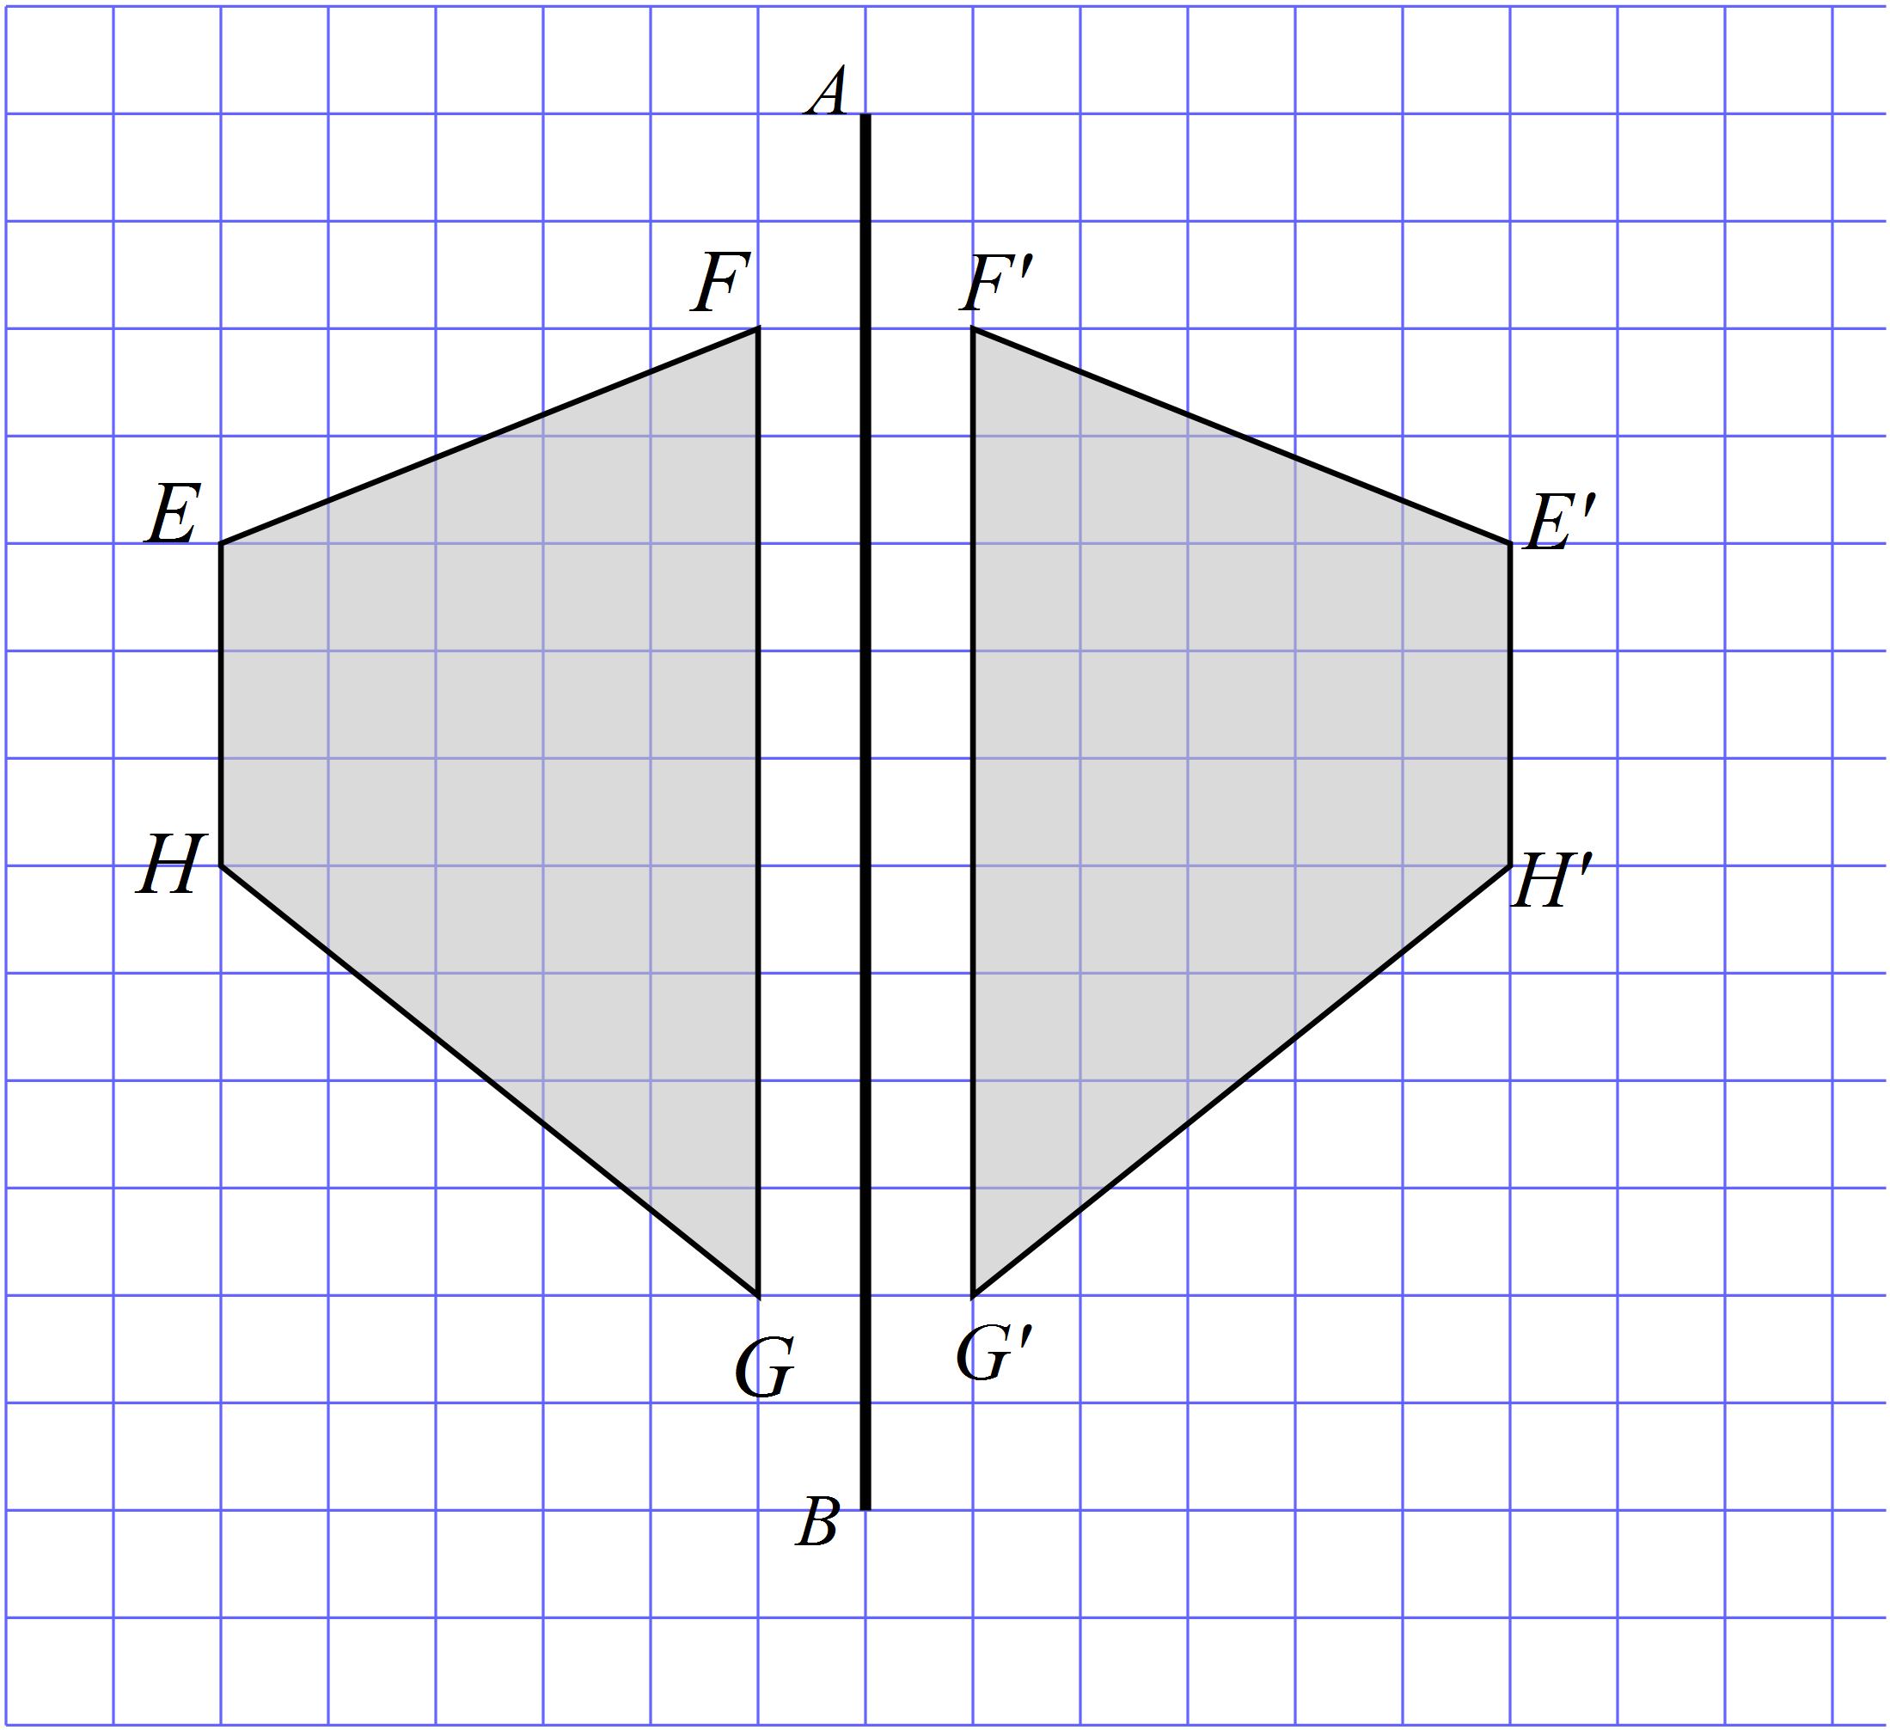

How many axes of line symmetry does the shape below have?
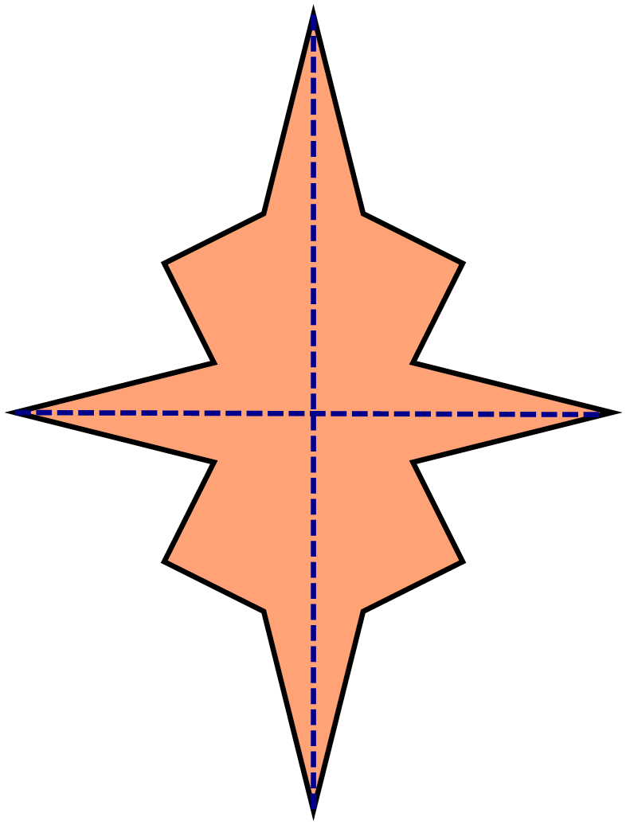

2 axes

Use geometric instruments to draw the image after PQRS when it is translated in the distance and direction of the arrow.
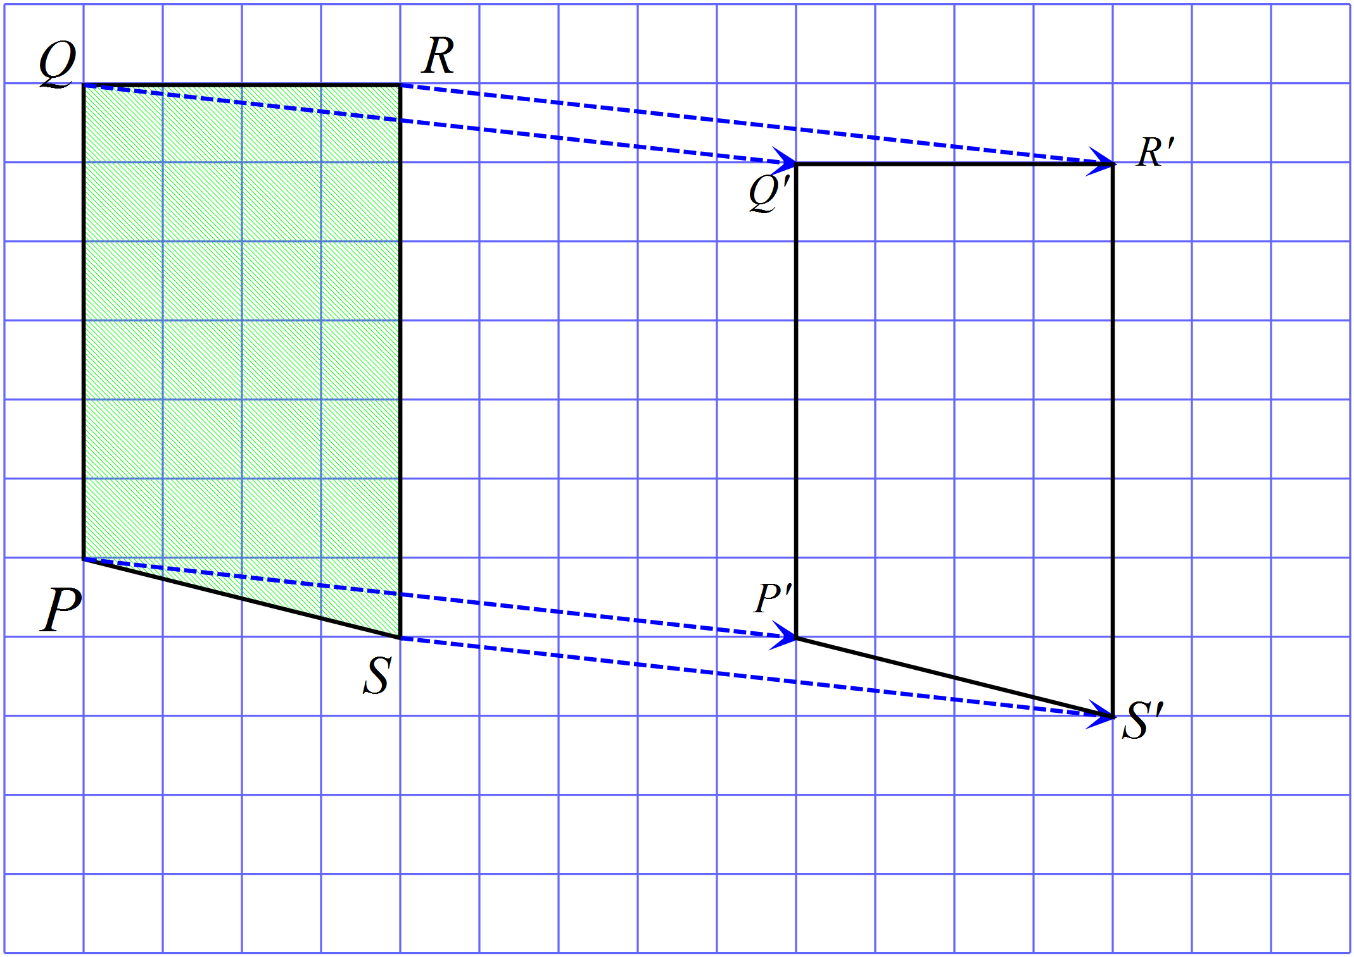

What order of rotational symmetry does the shape below have?

2 4 6 8
Use geometric instruments to draw the image after ABCD is rotated through 180º in a clockwise direction about N.
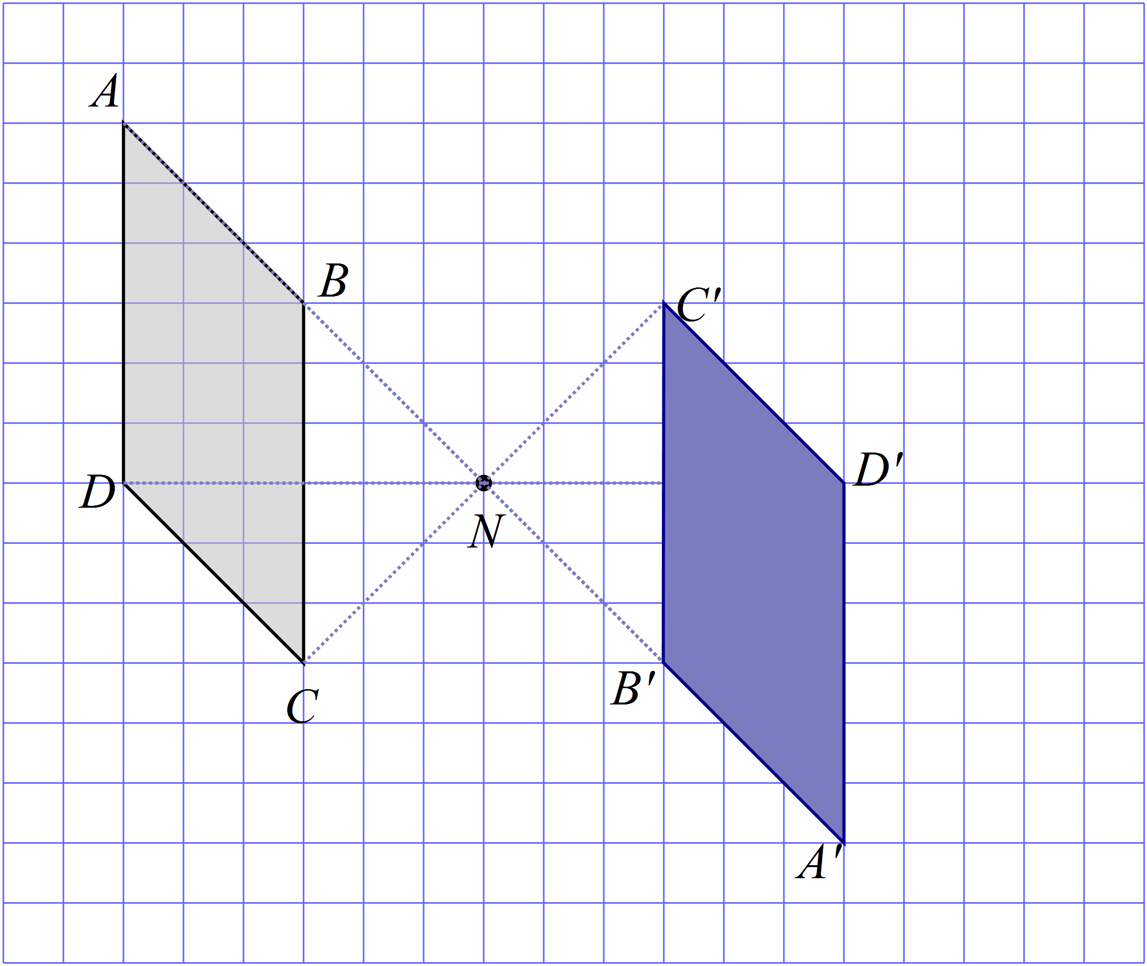

The figure PQR could be transformed to the figure by:

Rotation through 180º.

Reflection.

Translation.

Rotation through 90º.

The triangle labelled A is reflected in the line XY.
Which triangle could be the image?

Draw any axes of line symmetry for the shape shown.
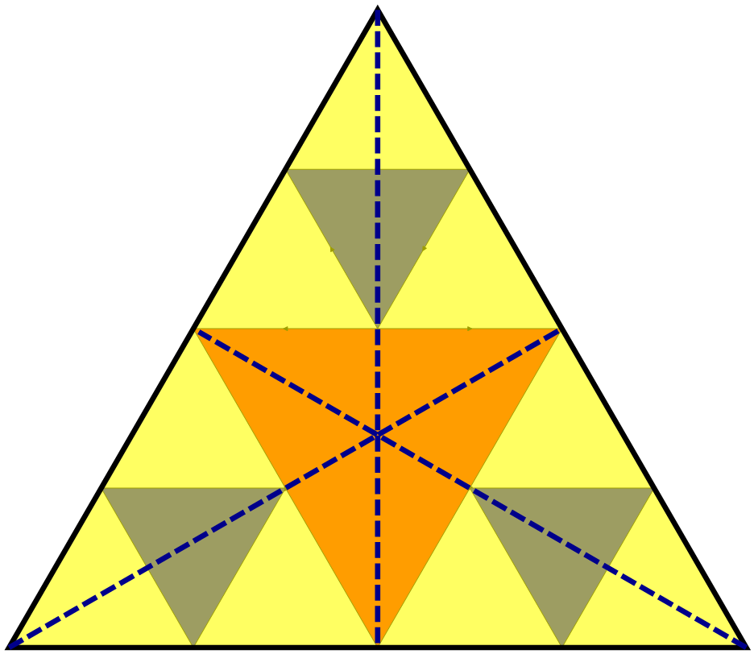

Which shape has rotational symmetry of order 6?

Complete the figure given that PQ is an axis of line symmetry.
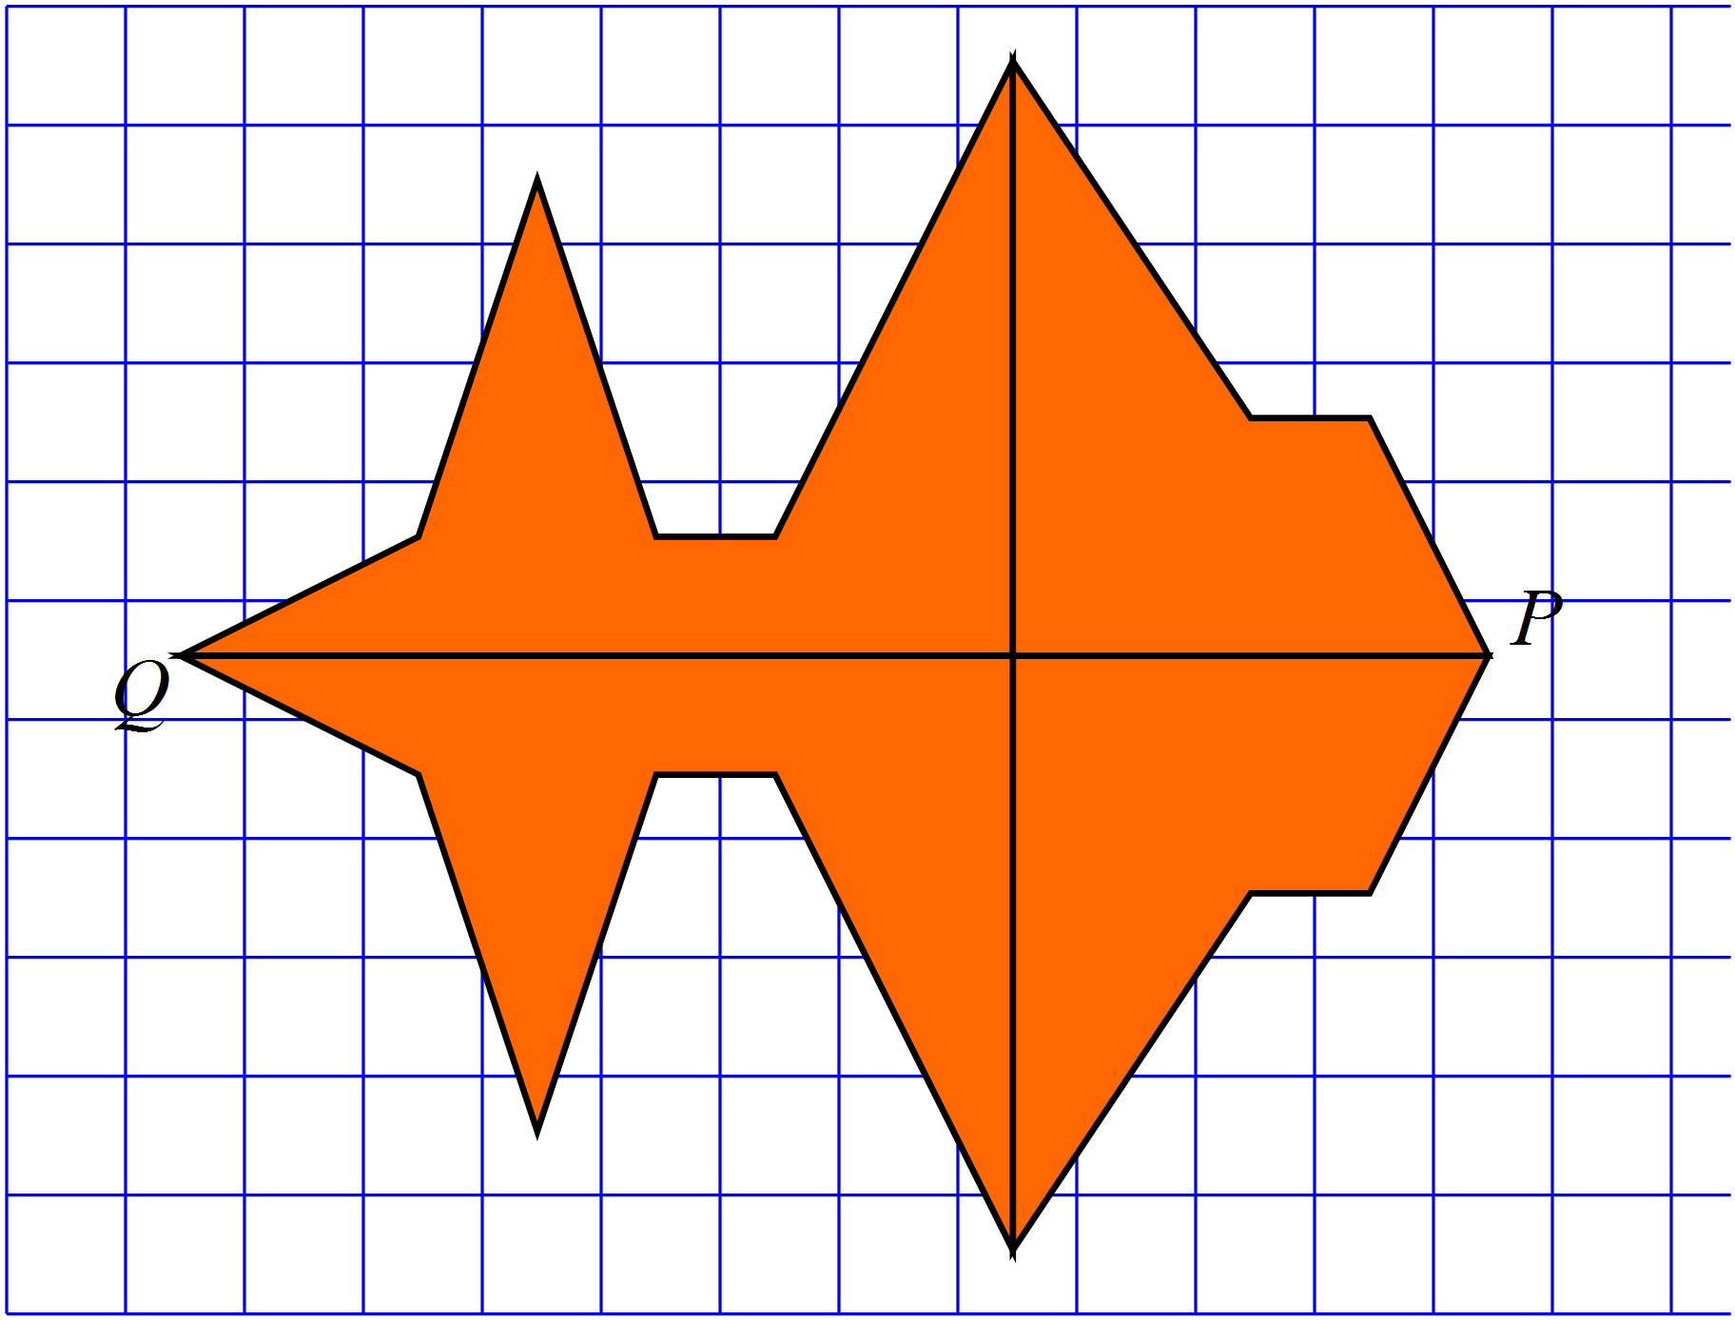

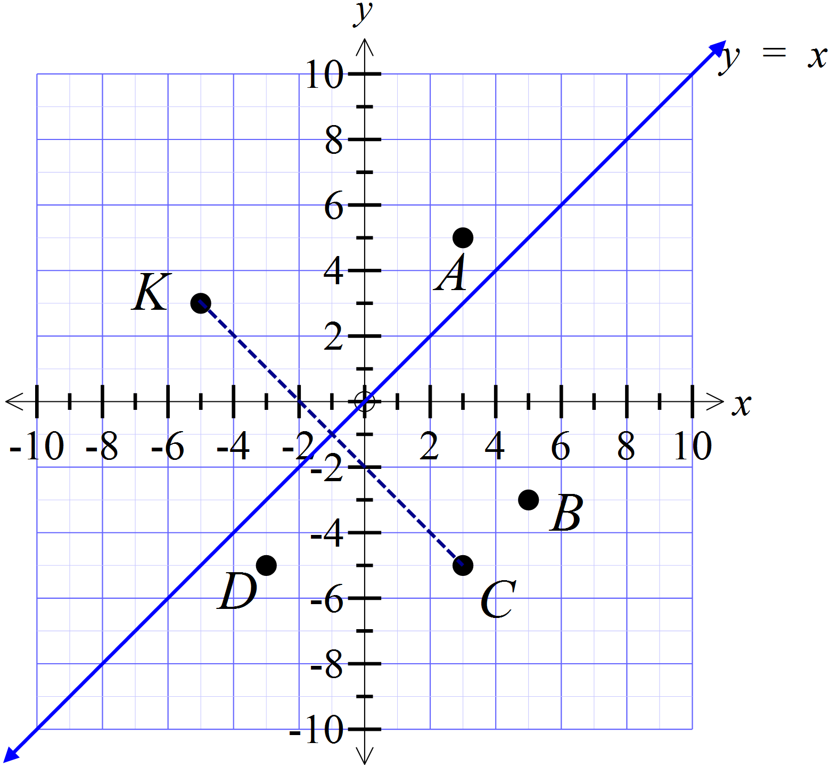The point K (-5, 3) is reflected in the line . Which point is the image after the transformation?

A (3, 5)

B (5, -3)

C (3, -5)

D (-3, -5)

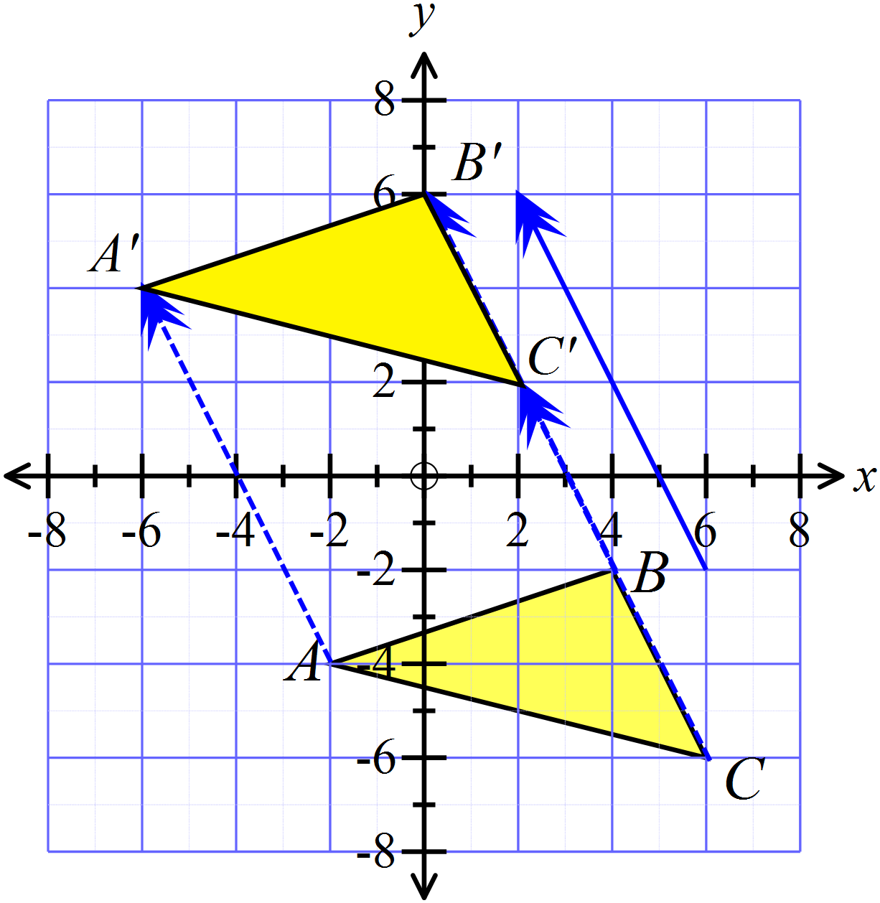Draw the position of the figure ABC after a translation in the direction and distance indicated by the arrow.

The point M (-6, -4) is rotated through 90º in an anticlockwise direction about the origin.
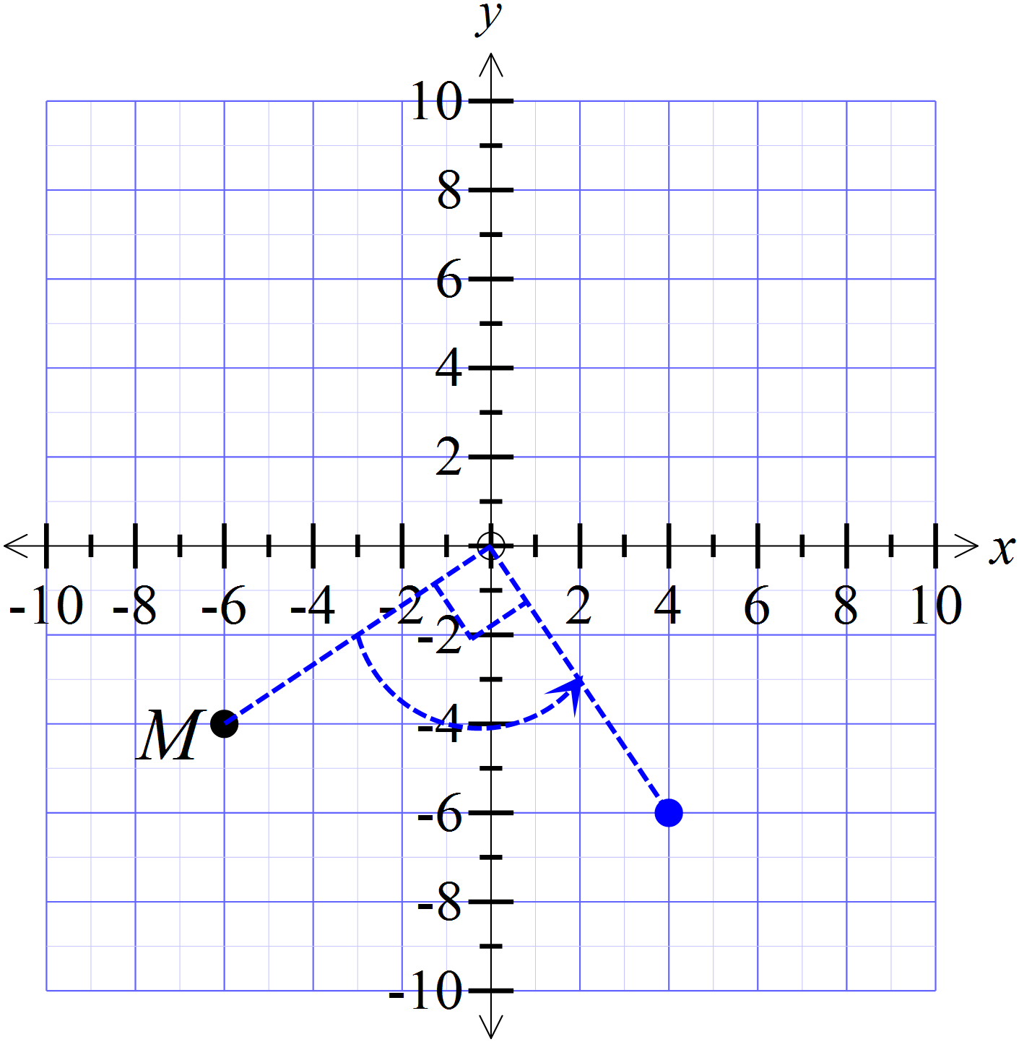Which are the coordinates of the image after the transformation?

(4, -6)

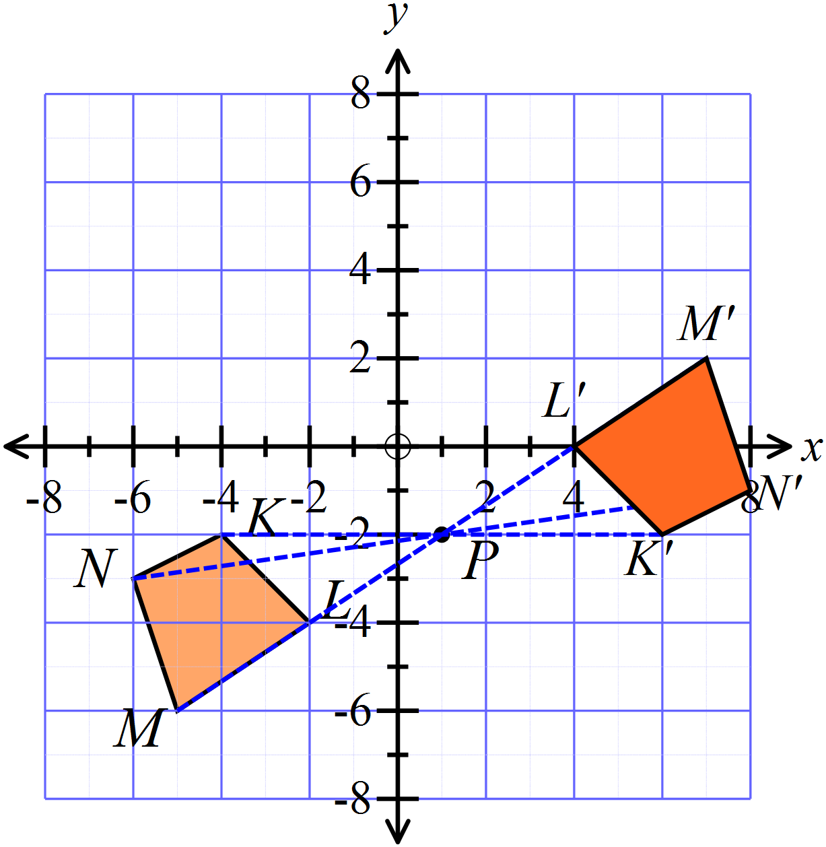Draw the position of the figure KLMN after a rotation through 180º in a clockwise direction about the point P( 1, -2)

The point T (-4, 8) is translated nine units to the right and twelve units down.
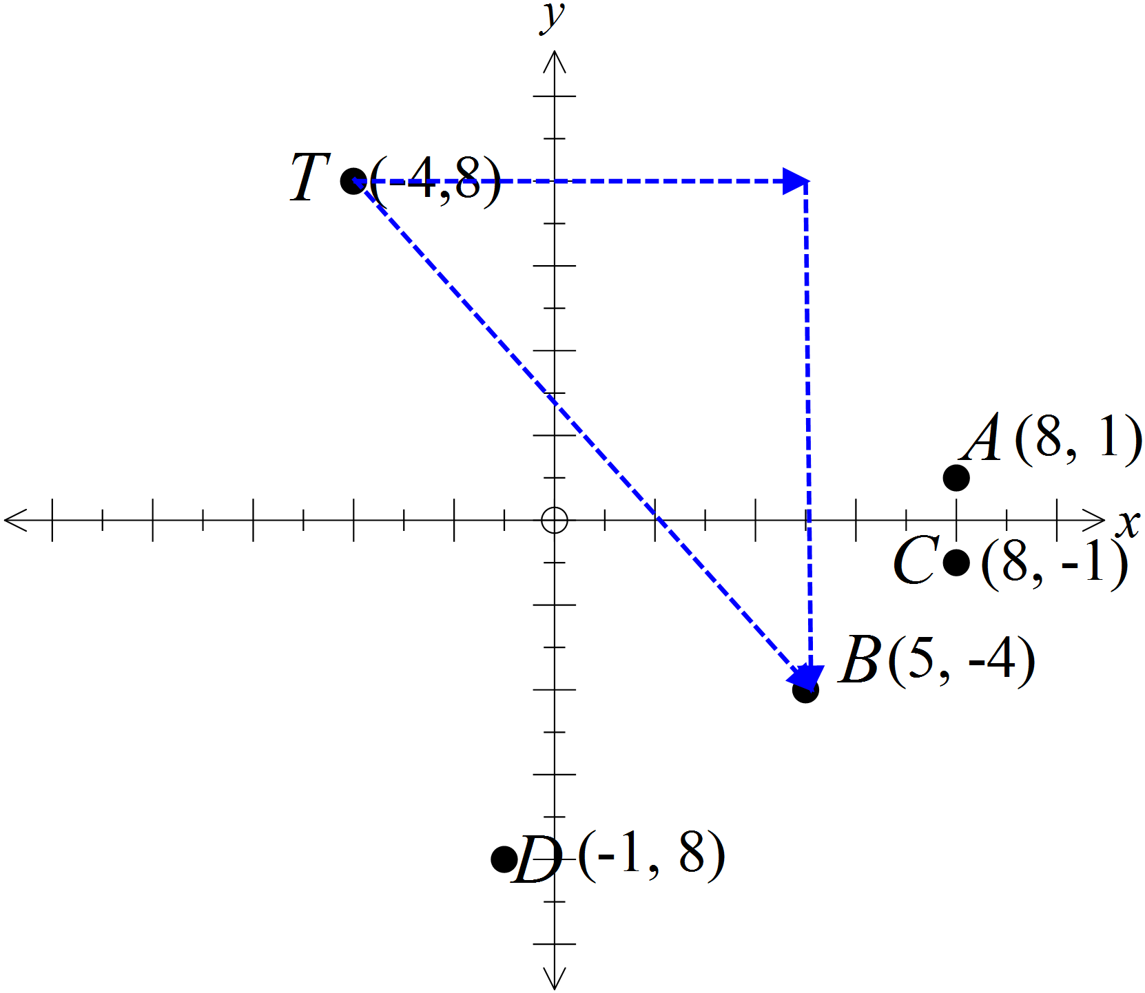Which point is the image after the transformation?

A (8, 1)

B (5, -4)

C (8, -1)

D (-1, -8)

Figure ABCD is moved to an image A’B’C’D’ by a single transformation.
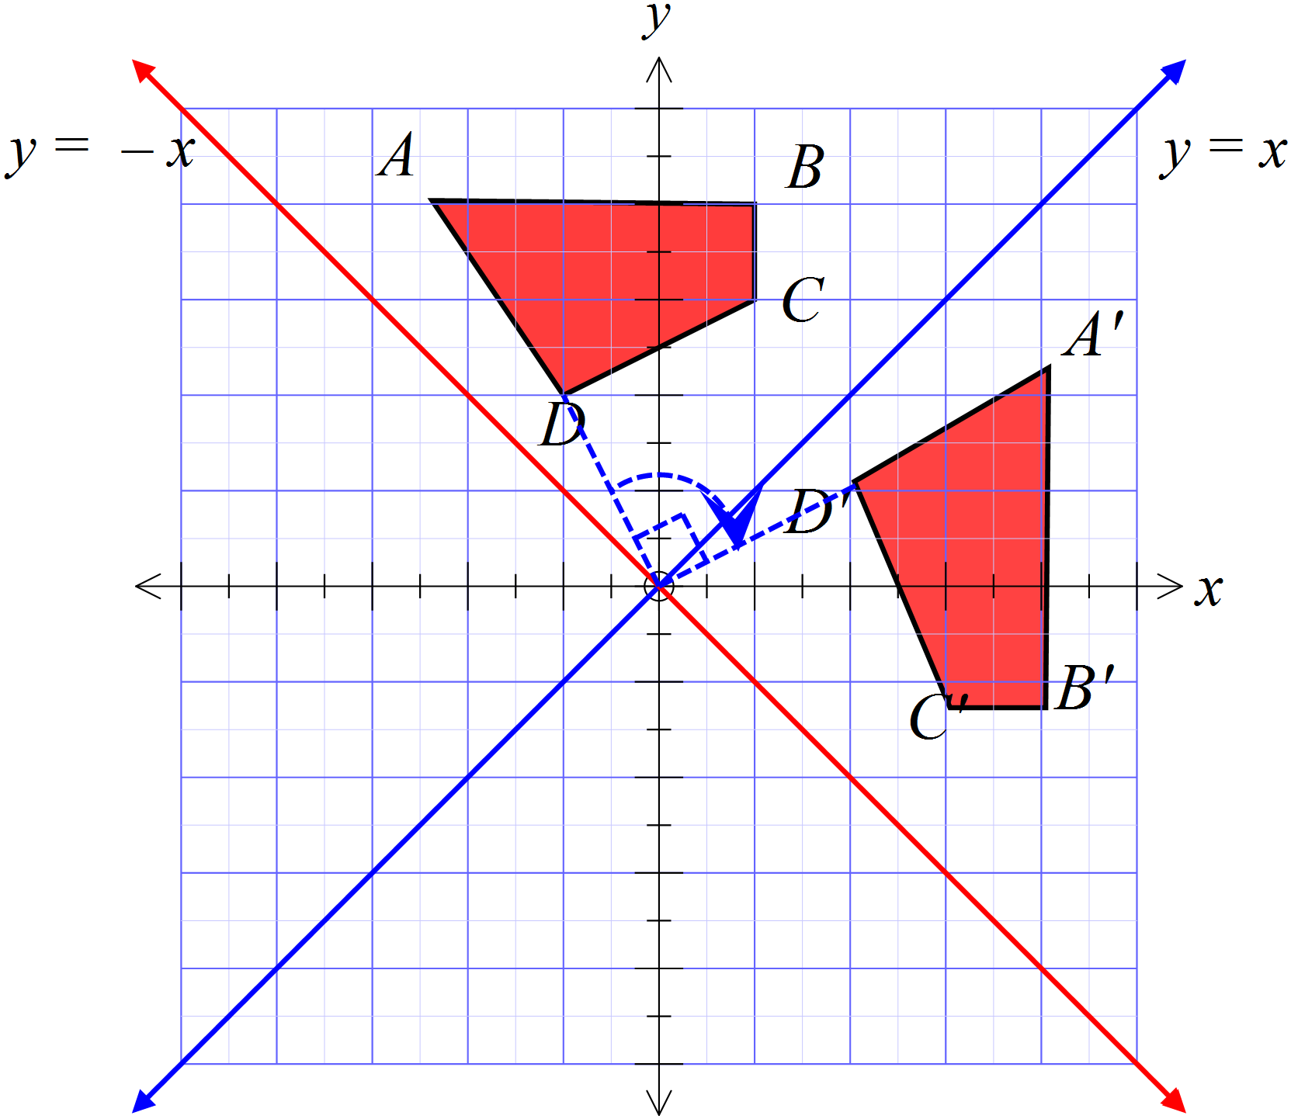What was the transformation?

A reflection in the line y = x.

A reflection in the line y = -x

An anticlockwise rotation of 90º about the origin.

A clockwise rotation of 90º about the origin.

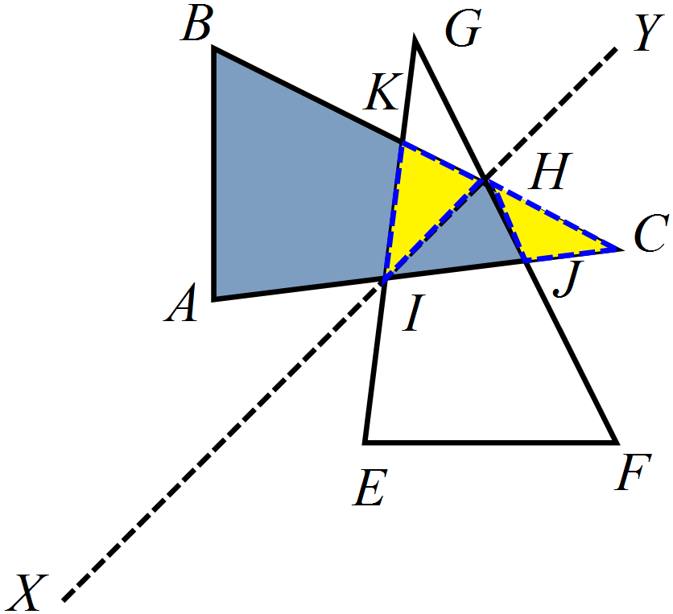The triangle ABC is reflected in the line segment XY, to give the triangle EFG.

Which is not a pair of congruent triangles?

Figure UVWX is moved to an image U’V’W’X’ by a single transformation.
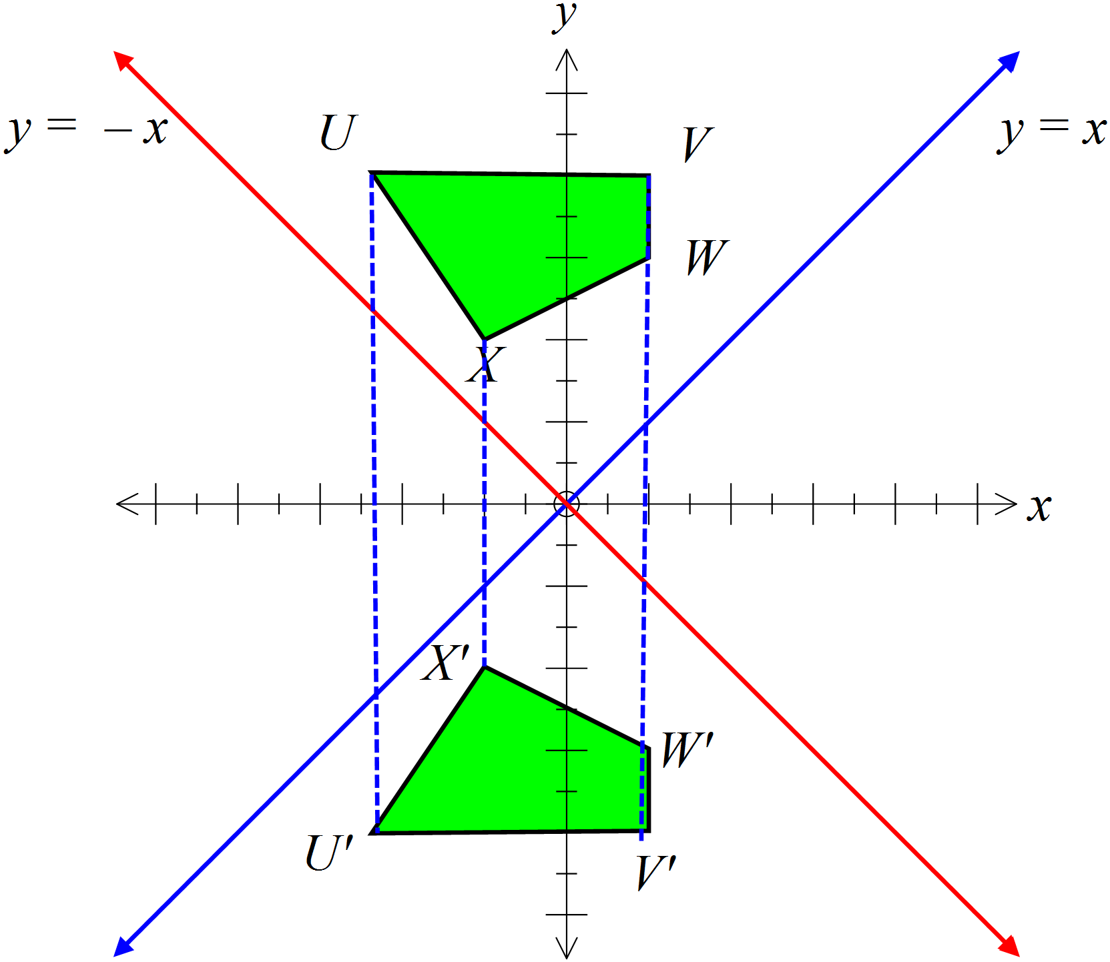What was the transformation?

A reflection in the x axis.

A reflection in the y axis.

A rotation of 180º about the origin.

A translation downward along the y axis..

It is flipped over, hence a reflection.

This geometric pattern was created by transforming congruent polygons.
Which statement is not true?

All of the polygons in the pattern are congruent.

All of the octagons in the pattern are congruent.

The pattern has line symmetry.

The pattern has rotational symmetry.

(Since there are squares and octagons,
not all are congruent)

A parallelogram ABCD has both its diagonals drawn, intersecting at E.
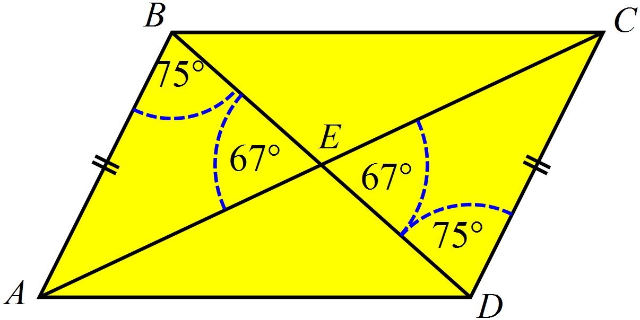
Which statement is true?

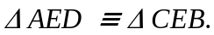

Can use AAS to show congruence.
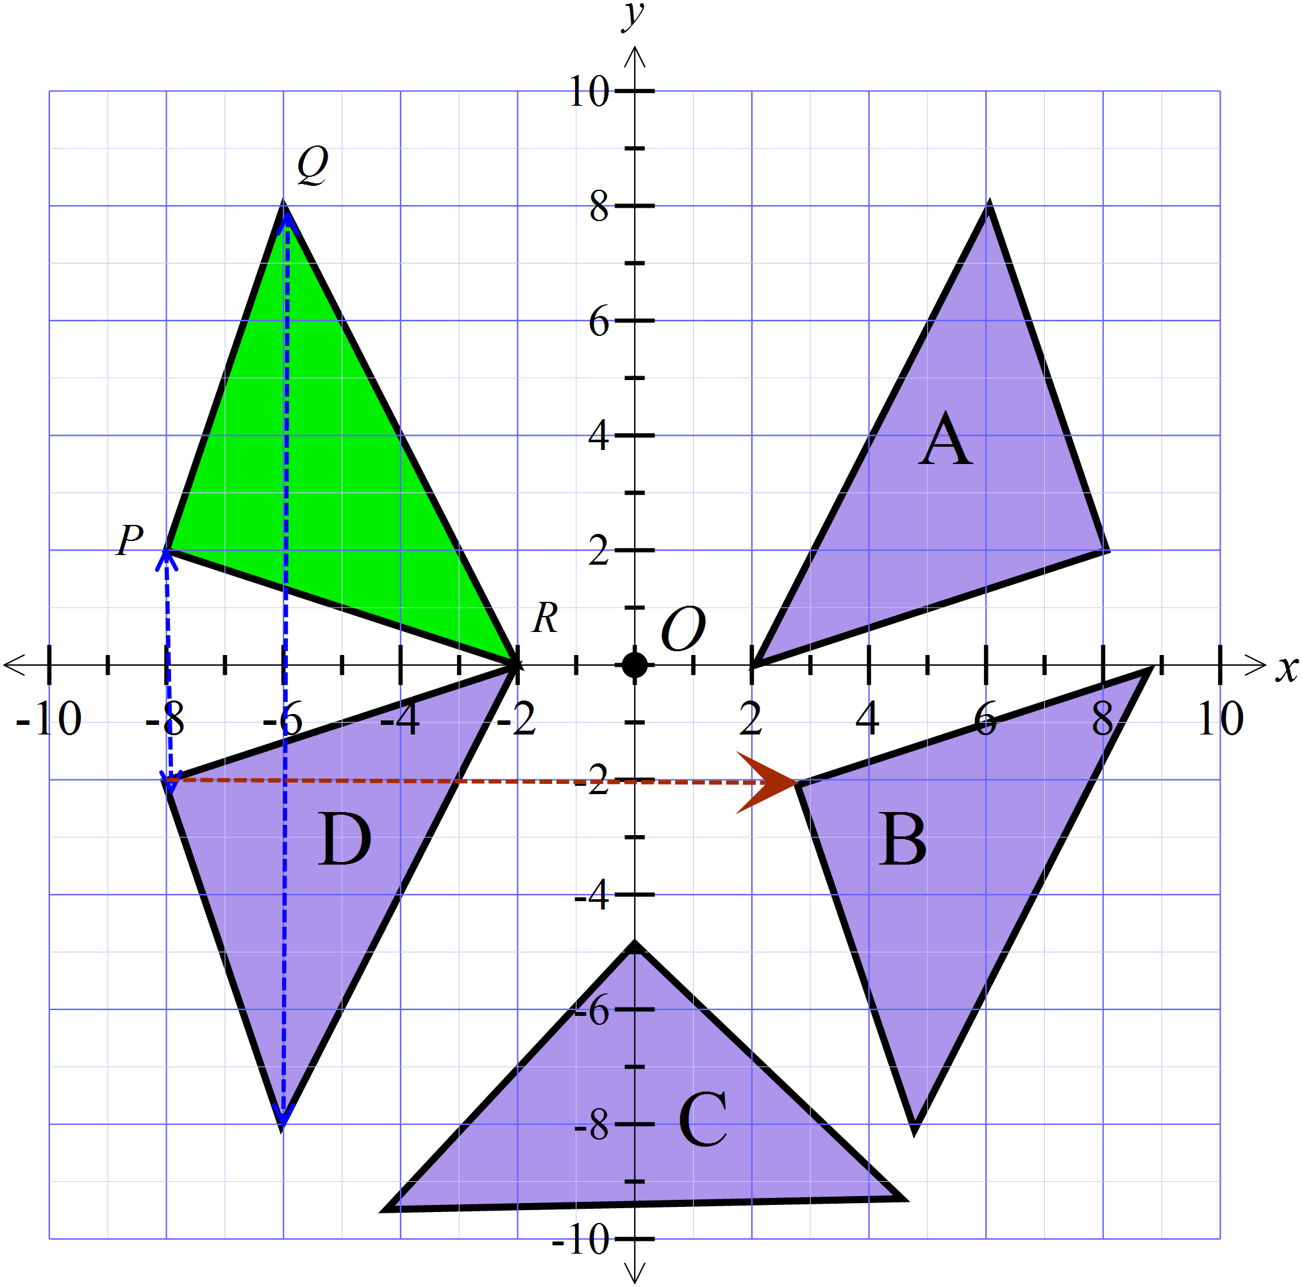 PQR is reflected in the x axis and then translated to the right.

Which figure is its image?

Triangle A

Triangle B

Triangle C

Triangle D

Reflection gives D then translation gives B.

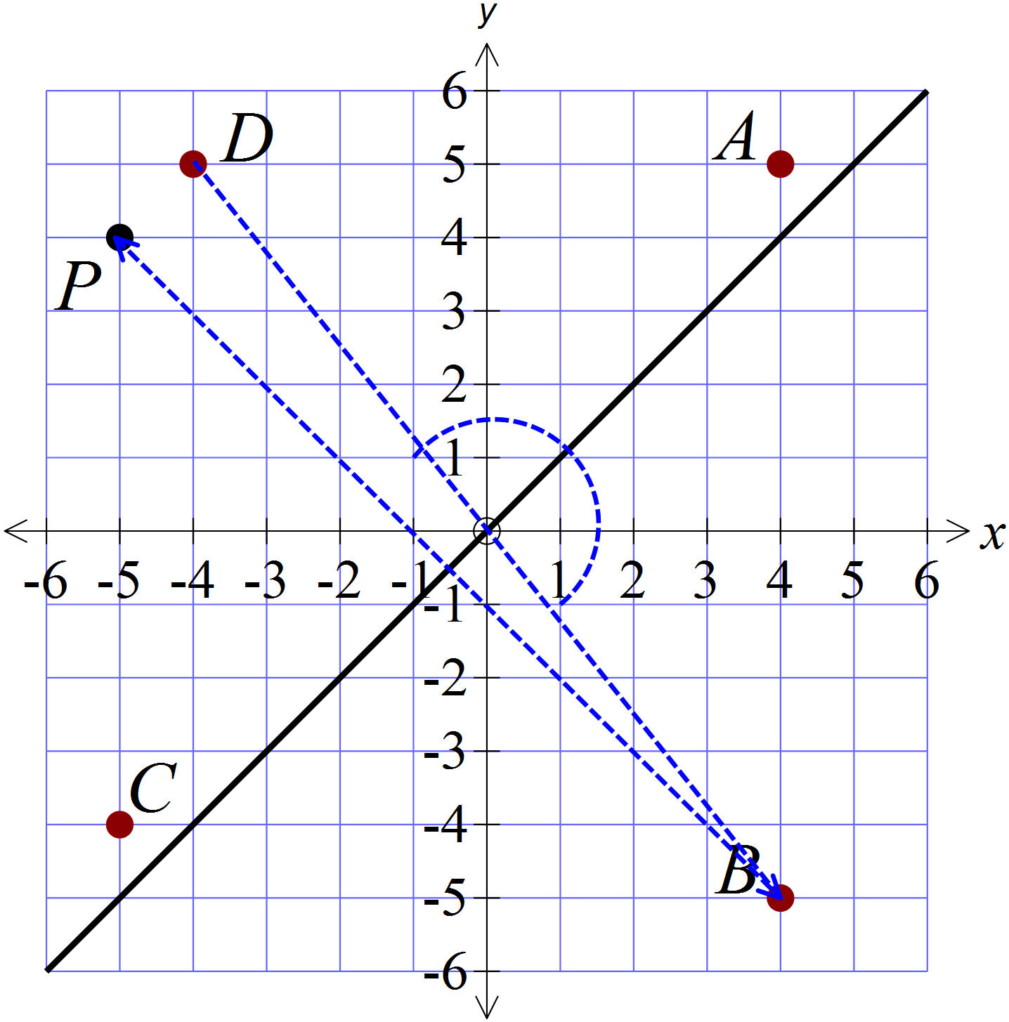The point P (-5, 4) is reflected in the line y = x and then rotated 180º in an anticlockwise direction about the origin.
Which point is the image after these two transformations?

A (4, 5).
B (4, -5).
C (-5, -4).
D (-4, 5).

Which of the congruence tests could be used to show that

Use the right angle
the 33º angle and
the common side
for AAS.

AAS RHS SAS SSS

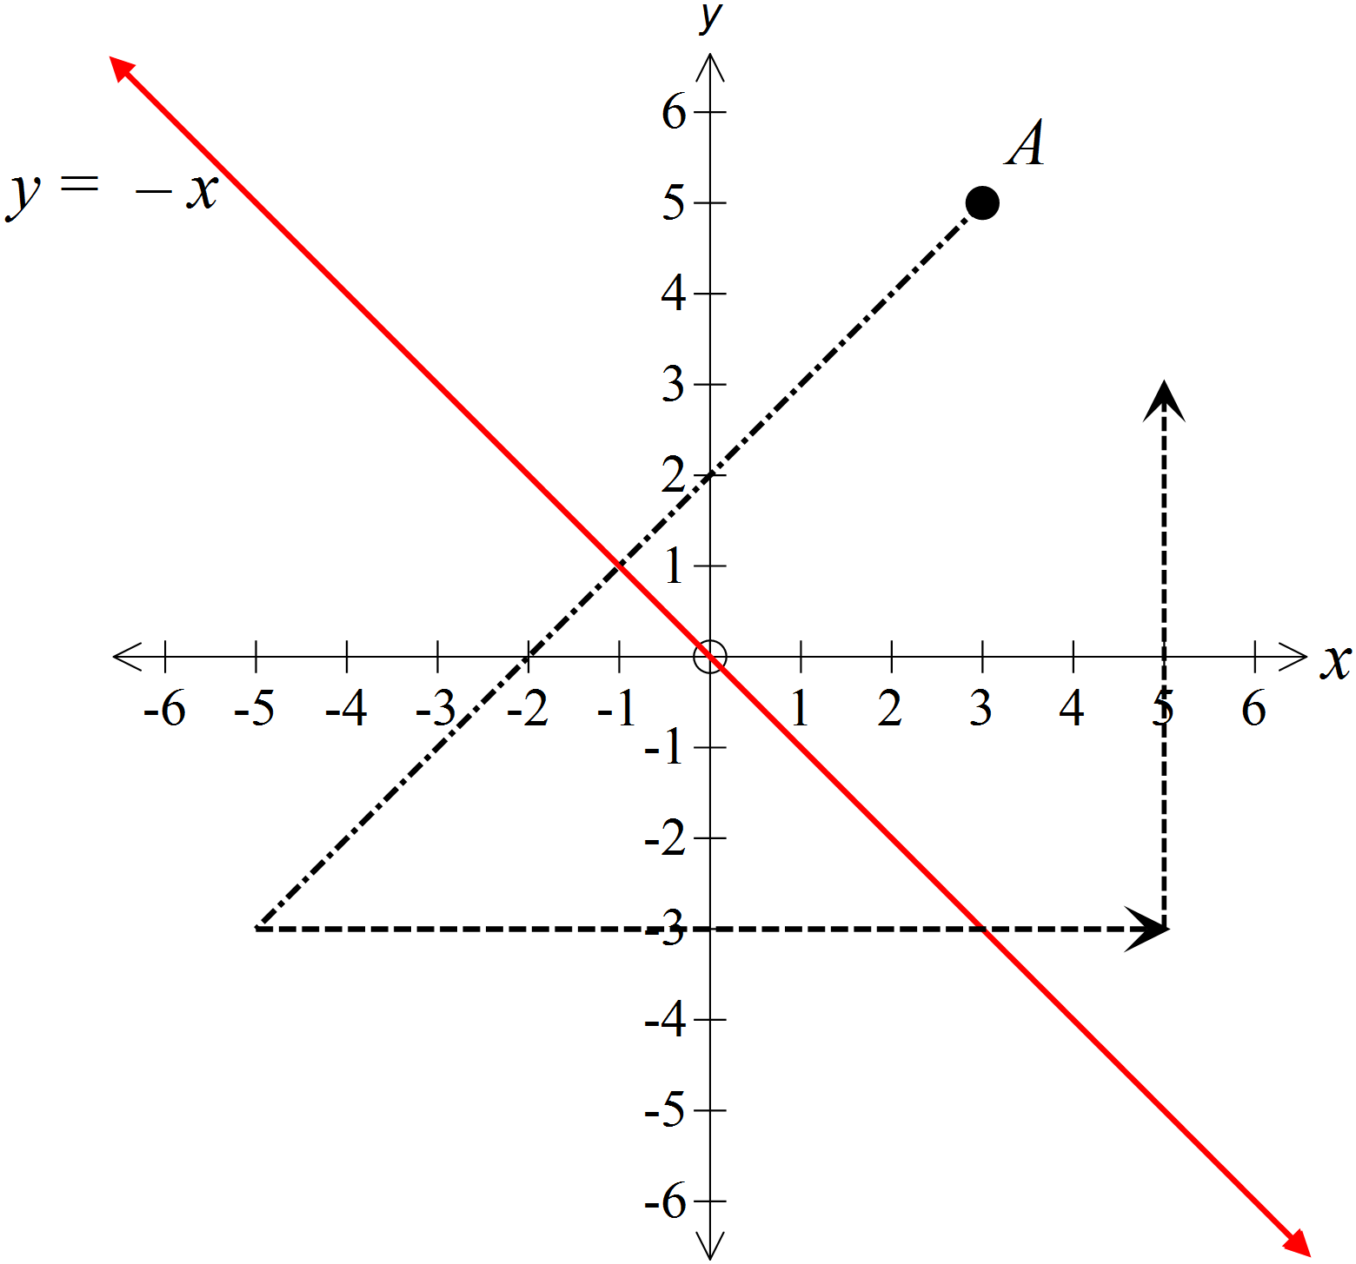The point A (3, 5) is reflected in the line y = -x and then translated 10 units to the right and 6 units upward.
Give the coordinates of the point which is the image after these transformations?

( 5 , 3 )

In the figure below, PQ = SR.
Which single additional piece of information would allow you to show that
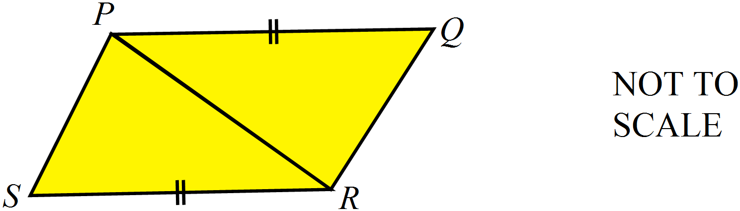
PR is a common side.

QR
PS
= would give SSS.
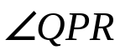
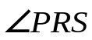
= would give SAS.

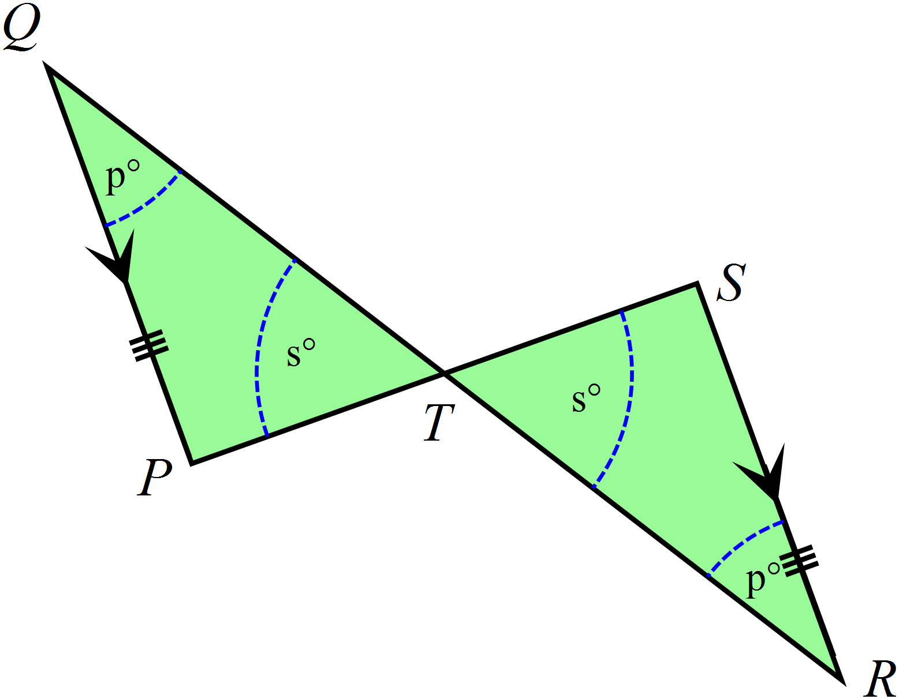QP || SR and QP = SR.
Which of the congruence tests could be used to show that

AAS
RHS
SAS
SSS

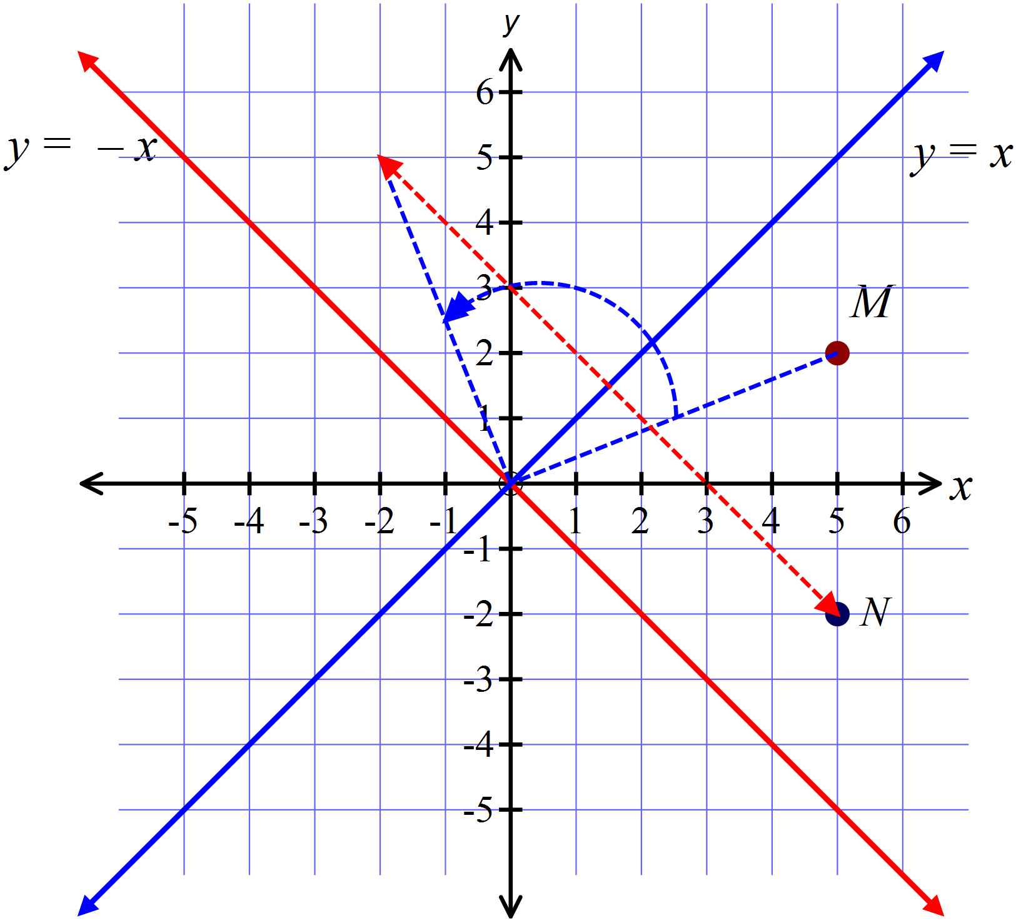The point M (5, 2) is rotated about the origin through 90º in an anticlockwise direction. What single reflection would then move the image to N(5, -2)?

A reflection in the line y = x.

Which of the congruence tests could be used to show that .

Using the common
side BC.

AAS RHS SAS SSS

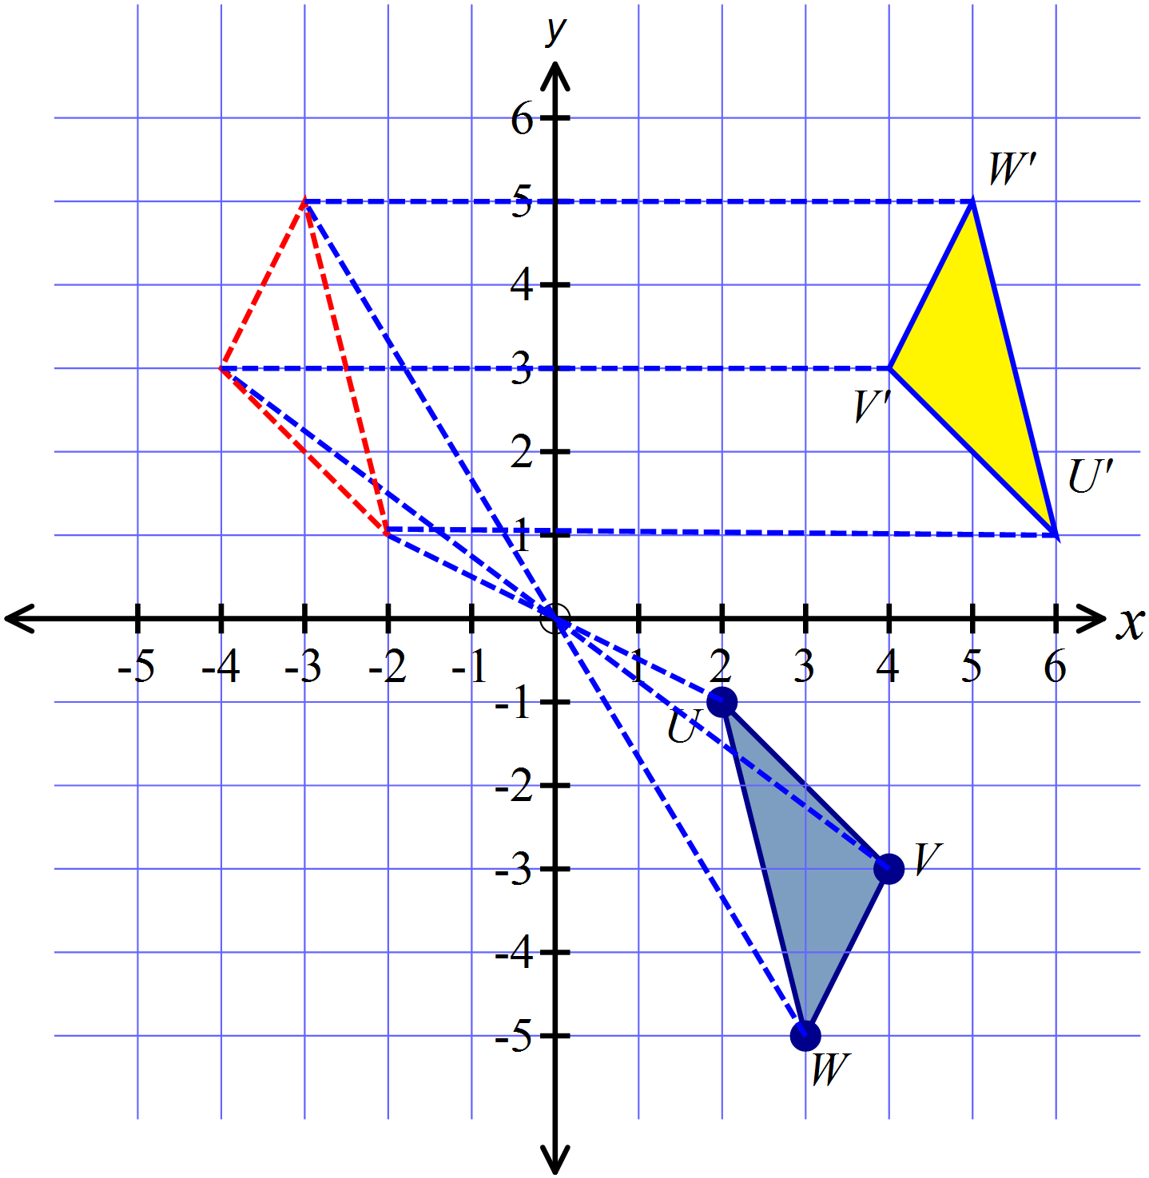The polygon UVW is rotated about the origin through 180º in a clockwise direction and then translated 8 units to the right. Draw the image U’V’W’ after these two transformations.

RX = SX, and X is the midpoint of PQ.
Which of the congruence tests could be used to show that

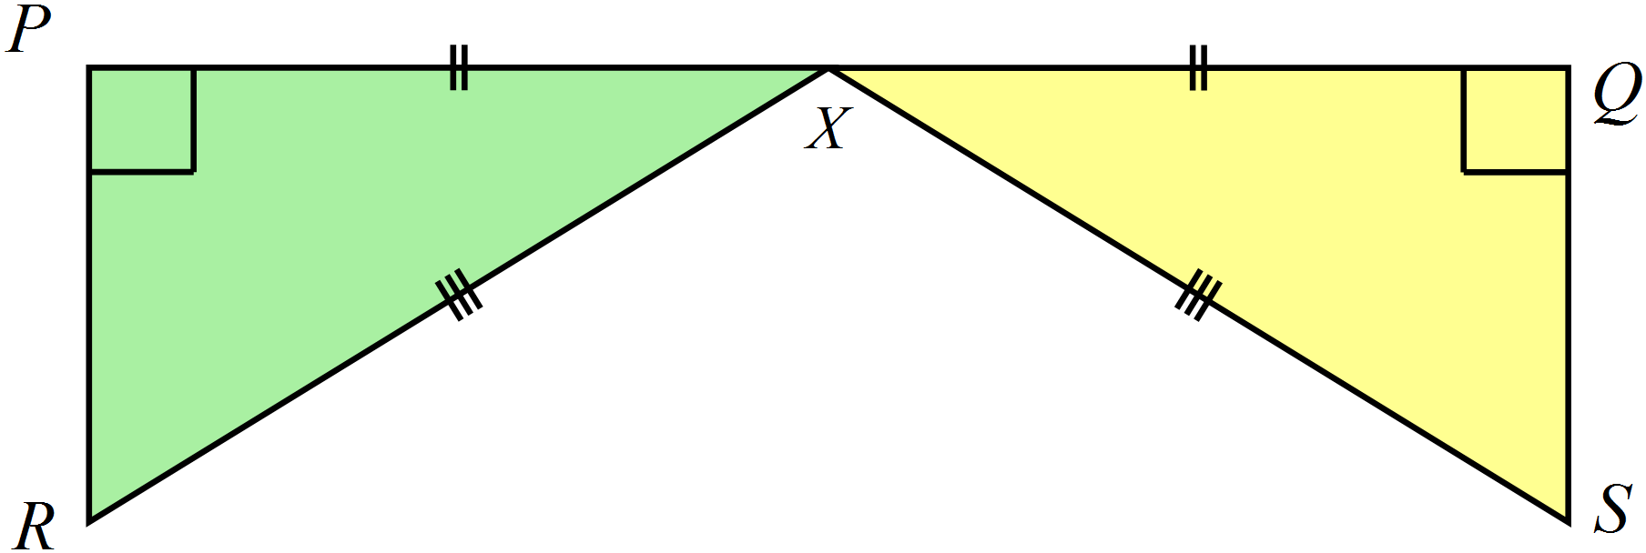

AAS RHS SAS SSS

Longer Answer Section

1. | (a) Complete the diagram below so that the figure has two axes of line symmetry.  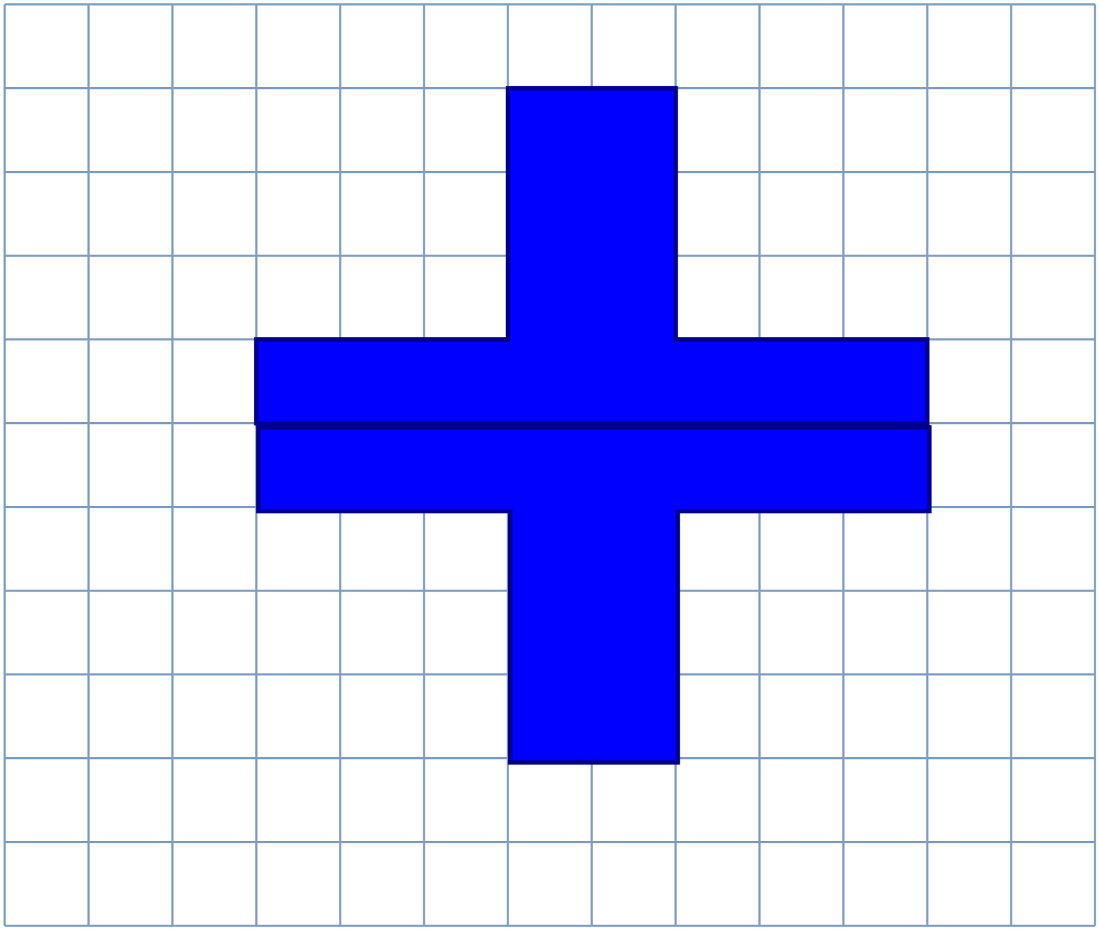  Others are possible. | 2
 | (b) Complete the diagram below so that the figure has rotational symmetry of order 3  .  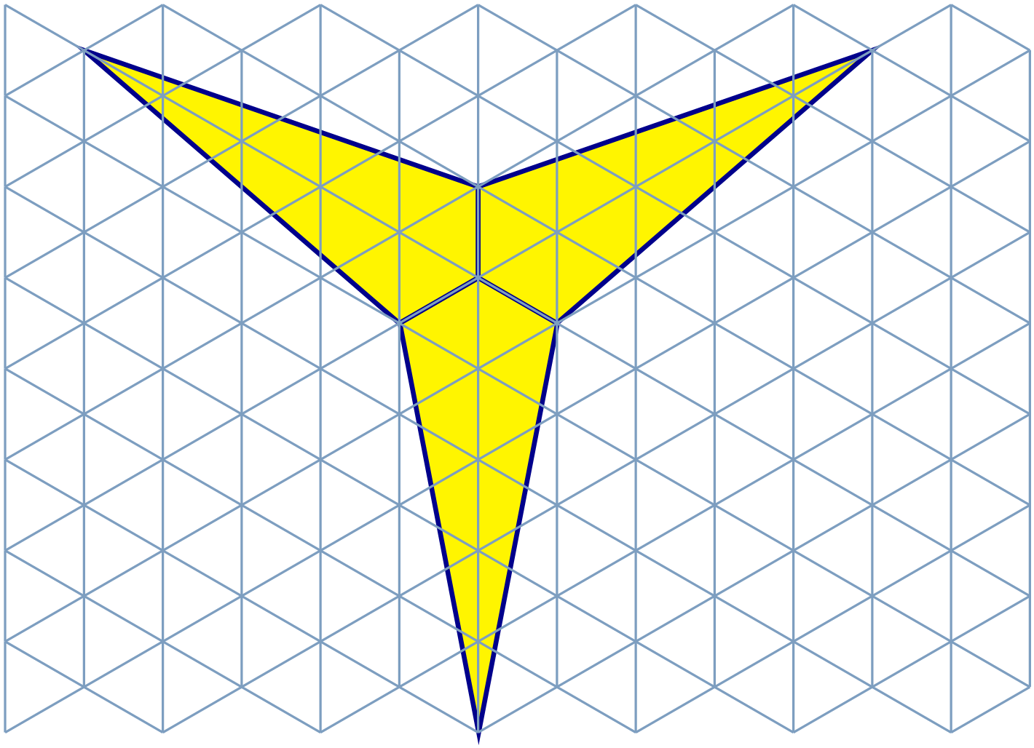 | 2
2. | (a) Draw a figure congruent to ABCD, by reflecting in the line y = x.  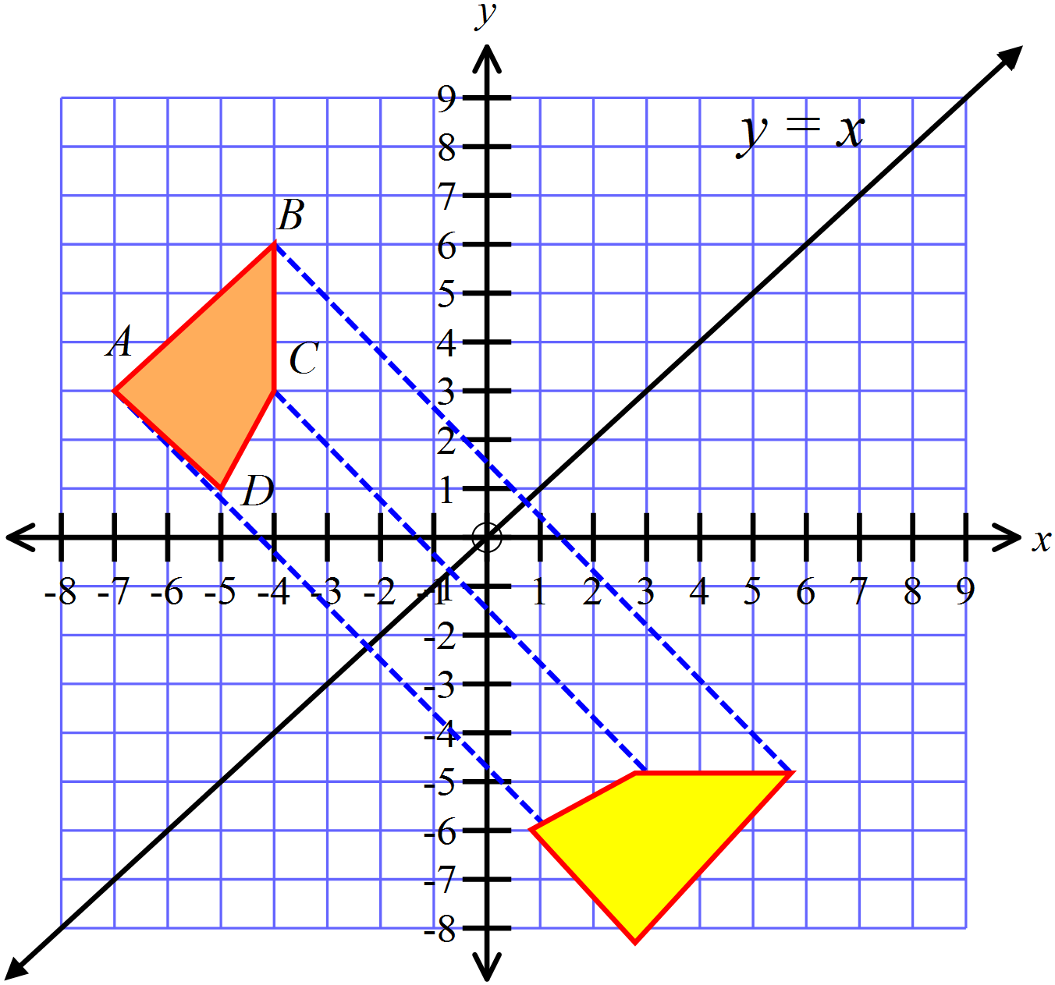 | 2
 | 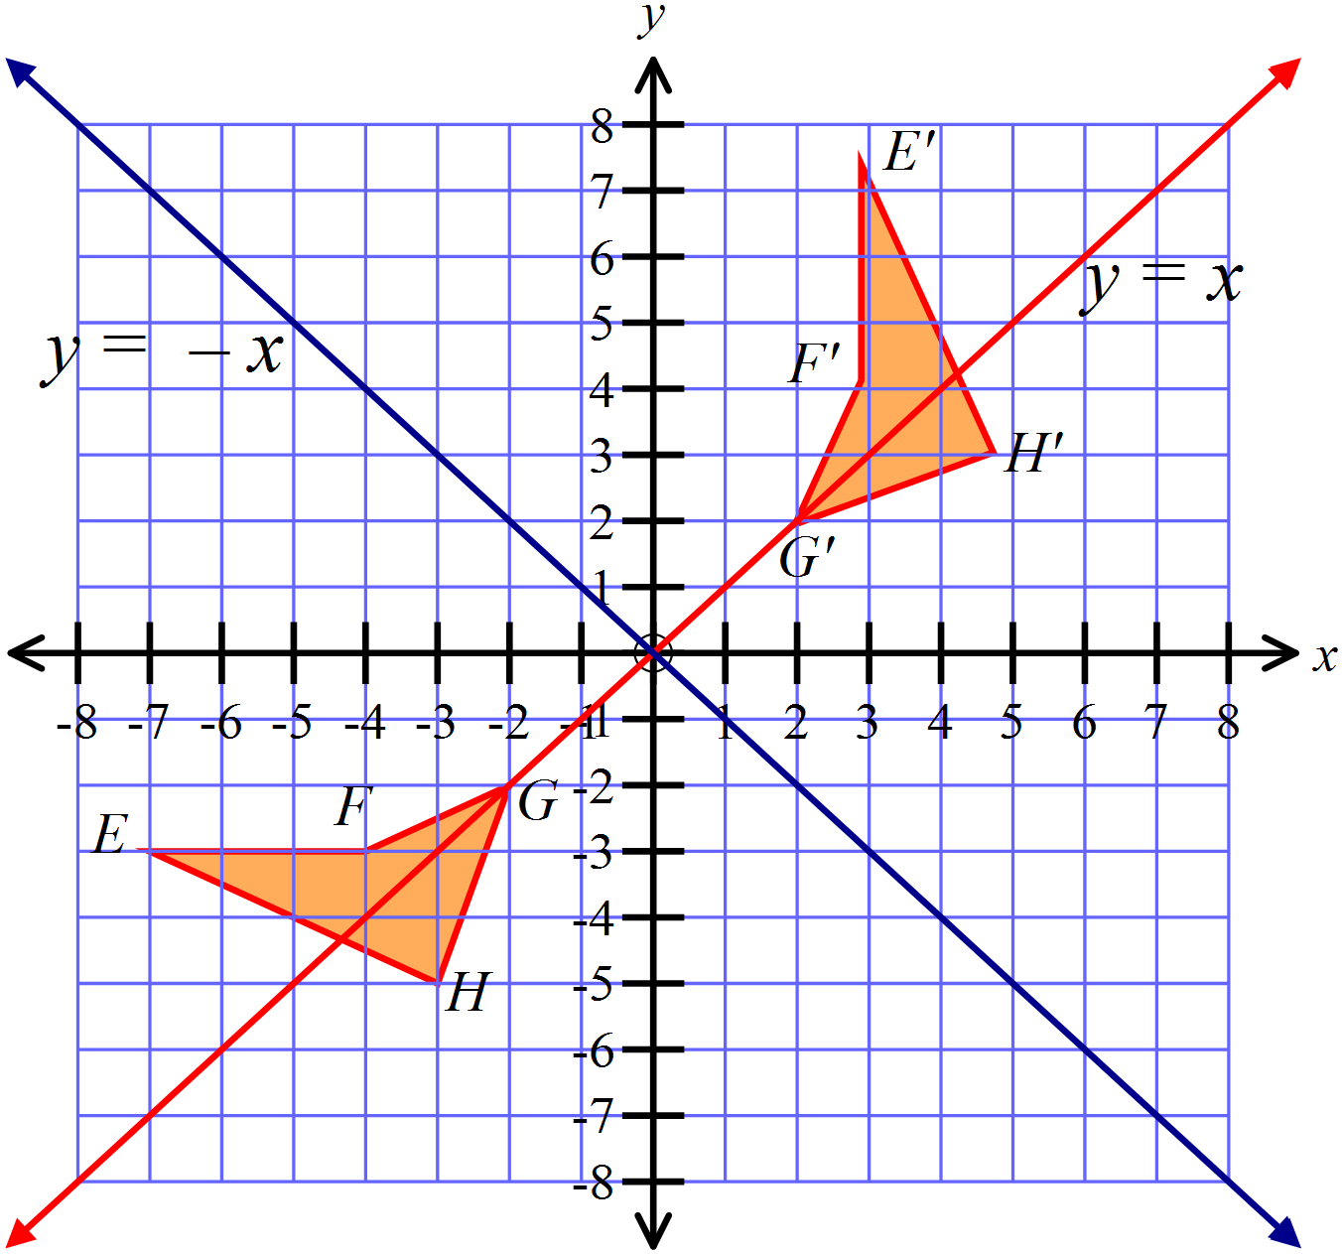(b)  Describe a single transformation that could move EFGH to its image E’F’G’H’.  A reflection in the line y = -x. | 1
3. | (a) Using the information provided on the diagram below, prove that  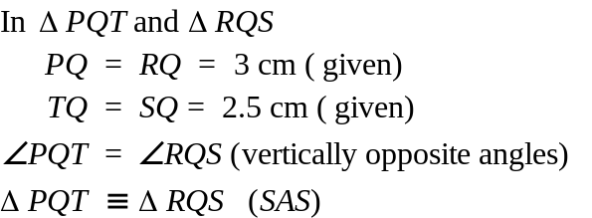 | 3
 | (b) In the figure below, and  Prove that  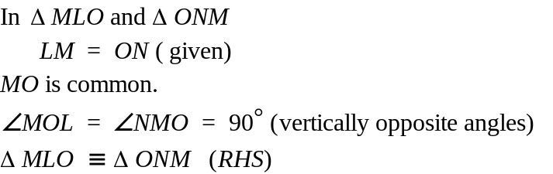 | 3

